Index of Facebook Recipe Collection # 4 by Page Number

- Homemade Krispy Kremes
- Chicken Dressing Recipe
- Quick Black Forest Torte
- Pizza Chicken
- Easy Crockpot Chicken Fajitas
- Grilled Picnic Taco Nachos
- Orange Fluff Jello Salad
- Cream Cheese Bars
- Crazy Pizza Bread
- Cheesy Pepperoni Twist Rolls Recipe
- Beef Tater Tot Casserole
- Buffalo Chicken Wontons
- Oriental Ramen Broccoli Cole Slaw
- Angie's Greek Tuna Salad Wrap
- Pumpkin Cream Cheese Truffles
- Tina's Mini Spinach And Bacon Quiches
- Bbq Biscuit Pie
- Tator Tot Taco Bake
- No Bake - Pecan Coconut Praline Cookies
- Pan Burritos
- Mini Fall Pumpkin Pie Croissants
- Mini Corn Dog Bites
- Famous Red Lobster Shrimp Scampi
- Melt In Your Mouth Chicken
- Crock-Pot Cheesecake
- Bacon Cheddar Pull-Apart Bread
- Pretzel Sandwich Cookie
- Crock Pot Scalloped Potatoes
- Cheese Doritos Chicken Taco Casserole
- Oven-Baked Frito Pie
- Buttermilk Ranch Cheeseball
- Stuffed Peppers
- Blackberry Pie Bars
- Fool's Toffee
- Root Beer Jelly
- Paula Dean's Delicious 5 Minute Fudge
- Fall Dip
- Bacon Cheddar Puffs
- Mini Apple Pie’s
- 3, 2, 1 Cake
- Billion Dollar Bar
- Tomato Basil Pasta
- Homemade Coffee Creamer
- Banana Pudding Poke Cake
- Pumpkin Cupcakes
- Pumpkin Better Than Sex Cake
- Easy Crockpot Chicken Fajitas
- Peanut Butter & Chocolate Lover's Trifle
- Chocolate Chip Cookie Cheesecake
- Pizza Hut Tuscani Creamy Chicken Alfredo
- Lemon Pepper Pork Chops
- Crockpot Cube Steak And Gravy
- Pumpkin Cheesecake Pie
- No Bake Italian Cake
- Chocolate Chip Pudding Cookies
- Cheesy Chicken Casserole
- Sugar Cookie Bars
- Slow-Cooker Salsa Chicken
- Outback Steakhouse Bloomin Onion
- Oven Baked Fajita
- Banana Bread With Honey And Applesauce
- Peanut Butter Cake
- Chicken Alfredo Casserole
- Oreo/Peanut Butter Cup No-Bake Dessert
- Salted Caramel Pretzel Bark
- Salted Nut Squares
- Enchilada Bake
- Texas Trash Warm Bean Dip
- Baked Broccoli
- Mcdonald’s Breakfast Burrito
- Sour Cream Graham Streusel Cake
- Beer Bacon Brittle
- Nacho Chicken & Rice
- Barbecue Beef Taco Plate
- Bbq Ranch Chicken Pizza
- Bacon Cheese Treats
- Million Dollar Dip
- Starbucks Lemon Loaf
- Bacon Cheeseburger Dip
- No Bake - Cream Cheese, Coconut, Snowball's
- Comfort Breakfast Bake
- Slow Cooker Bacon-Wrapped Apple Chicken
- Baked Crab Rangoon
- The Cheese Dip That Will Make You Famous
- Crockpot Beef And Broccoli
- Broccoli Cheese Soup Recipe
- Crockpot Sweet & Sour Meatballs
- Mudslide Jello Shots
- No Bake Eclair Cake
- Real Cucumber Sandwiches
- Baked Mozzarella Chicken Rolls
- Dreamsicle Salad (Sugar Free)
- Caramel Apple Cheesecake Bars
- Slow Cooker Chicken And Dumplings
- Beef Noodle Bowl
- Cream Cheese Sausage Balls
- French Dip Crescents
- Breakfast Pizza
- Crab & Cream Cheese Snacks
- No Bake Pumpkin Cheesecake

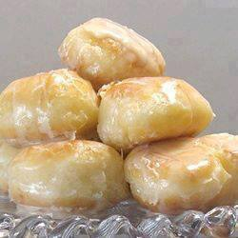
Homemade Krispy Kremes
Ingredients:
3 tbsp milk
3 tbsp boiling water
1 tsp dry active yeast
8 oz all purpose flour (a little under 2 cups - I recommend you measure and weigh. See my note above)
1 1/2 oz sugar (about 3 tablespoons)
1 egg
1 oz butter, cold to room temperature (just don't melt it, okay?)
dash of salt
Enough oil to cover the bottom few inches of a wok, or a deep fryer.
Directions:
In a large measuring jug, combine the milk and boiling water. Add a teaspoon of the sugar and the yeast. Stir it gently, then leave it in a warm place for the yeast to activate (aka foam).
In a large mixing bowl, combine the flour, the rest of the sugar, and the salt. Cut in the butter using your fingers or a pastry blender, until it resembles crumbs.
Add the egg (give it a quick beat) and yeast mixture to the flour mix, and mix into a smooth dough. This usually takes about 5 minutes of mixing.
Turn the dough out onto a lightly-floured counter and knead for about 5 to 10 minutes—it should feel springy and little bubbles should form under the surface. Place it back in the bowl, cover with a cloth or plastic wrap, and let rise for about an hour until double in size.
Once risen, place the dough onto the counter and cut it into 4 pieces. One piece at a time, stretch it into a long rope about an inch to an inch and a half wide. Cut strips about an inch long, ball em up with your hands, and place them on a baking tray or wire rack to wait.
Cover the doughnuts holes with a cloth to rise while you heat the oil to 375F.(190 c)
Place the doughnuts into the oil and fry until golden brown on each side, about 2 minutes. Be sure to fry only a few at a time so they don’t overcrowd and stick together.
Drain on a paper towel or wire rack over a cloth, before glazing them. Be sure to glaze them warm, or else they won’t get that delicious coverage!
Glaze:
1/3 cup butter
2 cups confectioners' sugar
1 1/2 teaspoons vanilla
4 tablespoons hot water or as needed
A brief note: I recommend a scale, as not all flours (and cup measurements) are made equal.
2 cups of my Canadian flour in my Canadian cups on my scale might be more or less than yours.
If you don't have a scale, start at 1 1/2 cups and work your way up from there.
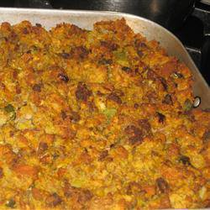
Chicken Dressing Recipe
Ingredients:
2 1/2 to 3 pound chicken
1 6 z pacjage Stove Top Dressing, herb flavored
1 can cream of mushroom soup
1/4 cup margarine melted
2 eggs, beaten
2 cup chicken broth
1/3 cup celery, diced
1/3 cup onion, chopped
1/2 cup milk
Stew chicken & de-bone it.
Mix all ingredients. Put in well greased 13 x 9 dish or pan. Bake 45 min at 350 degrees. Let stand 15 - 20 minutes before serving.

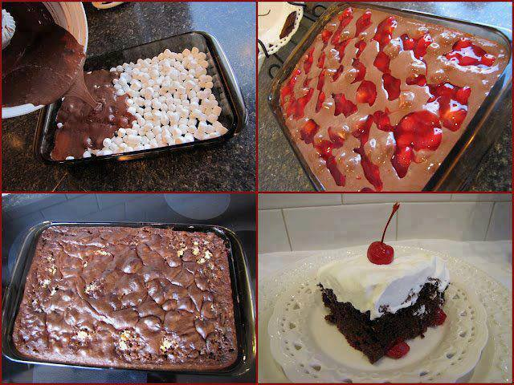
Quick Black Forest Torte
If you need to make a great dessert in a pinch here is a good one that always ends up all gone before you turn around..
Ingredients:
4 cups mini-marshmallows
1 chocolate cake mix
1 can cherry pie filling
1 large container of Cool Whip (or 2 cups whipping cream)
Method:
Pour four cups of mini-marshmallows into a greased 9x13 inch cake pan.
Prepare chocolate cake mix according to directions on package. Pour over marshmallows.
Spoon cherry pie filling evenly over cake.
Bake at 350°F for about 50 minutes...or until toothpick inserted comes out clean.
Cool.
Top with whipped topping. (If using whipping cream, whip 2 cups of cream with 3 Tablespoons sugar and 2 teaspoons vanilla until almost ready to form peaks.)
Serves 15.

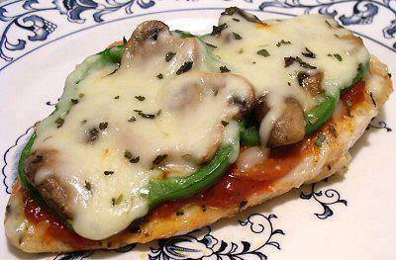
PIZZA CHICKEN
Ingredients
1 boneless chicken breast, pounded flat if thick
Salt, pepper, garlic powder and Italian seasoning, to taste
1 tablespoon pizza sauce
4 slices pepperoni
1 teaspoon butter or oil
2 fresh mushrooms, sliced
2 thin green pepper rings
1 ounce mozzarella cheese, shredded
Season the chicken with salt and other seasonings; grill. Meanwhile, sauté the mushrooms and pepper rings in butter or oil until slightly tender, but not mushy; set aside. Spread the sauce over the chicken, then top with the pepperoni, the pepper rings, mushrooms and then finally, the cheese. Sprinkle with a little additional Italian seasoning, if desired. Bake at 350º about 10-15 minutes or until hot and the cheese is melted. Serve at once.
Makes 1 serving
Can be frozen but the peppers will get soft
Per Serving: 310 Calories; 16g Fat; 36g Protein; 3g Carbohydrate; 1g Dietary Fiber; 2g Net Carbs

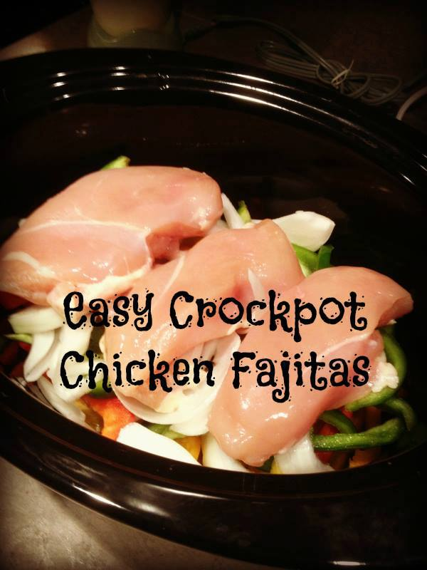
Easy Crockpot Chicken Fajitas
INGREDIENTS
1 lb. of Chicken Breasts (or you can use steak strips), 3 Peppers (Green, Red & Yellow) sliced, 1 Onion sliced ,1 Package of Taco Seasoning, Flour or corn tortillas
Toppings - sour cream, cheese, guacamole, etc.
...INSTRUCTIONS
Slice peppers and onions then place them on the bottom of the crock pot
Put Chicken on top of peppers and onions
Sprinkle taco seasoning on the top
Cook on low for 6-8 hrs. (or high for 3-4)
The chicken looks burnt but it's just crispy. Shred everything up and mix in the juice.
Serve with tortillas and all the toppings - sour cream, guacamole, cheese, lettuce, etc.

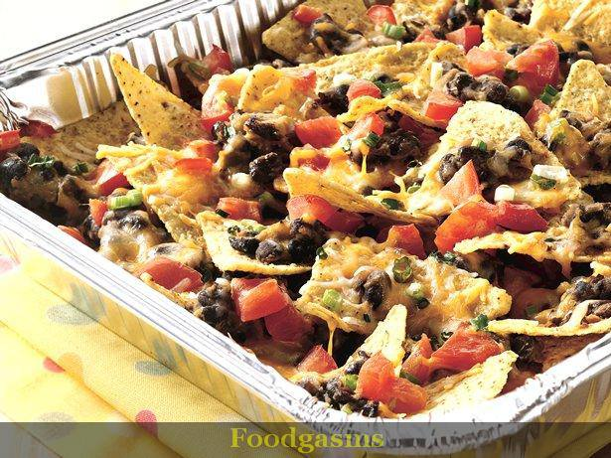
Grilled Picnic Taco Nachos
Ingredients:
5 cups tortilla chips
1 can (15 oz) black beans, drained, rinsed and mashed
1 can (4.5 oz) chopped green chiles, drained
2 teaspoons taco seasoning mix (from 1-oz package)
2 plum (Roma) tomatoes, chopped
2 medium green onions, sliced (2 tablespoons)
2 cups finely shredded Colby-Monterey Jack cheese blend (8 oz)
Directions:
1. Heat gas or charcoal grill. Spray 12x18-inch foil pan with cooking spray. Spread tortilla chips in pan.
2. In medium bowl, mix beans, chiles and taco seasoning mix; spoon evenly over tortilla chips. Top with tomatoes and onions. Sprinkle with cheese. Cover pan with foil.
3. Place foil pan on grill over medium heat. Cover grill; cook 8 to 10 minutes or until cheese is melted. Carefully remove foil.

Orange Fluff Jello Salad
Ingredients:
1 large package Cook and Serve vanilla pudding
1 large package orange jell-o
2 cups water
1 16 oz Cool-Whip (lite or fat-free is fine)
1/2 bag mini marshmallows
1 can pineapple tidbits (Any size, depending on your preference)
1 can mandarin oranges (Any size, depending on your preference)
2 bananas, sliced (Optional, put in before serving so they don't turn brown in the fridge)
Directions:
Mix together pudding, Jell-o, and water over medium heat until it boils. Remove from heat and pour into a large mixing bowl. Refrigerate until mixture has thickened (about an hour). Beat until creamy. Fold in Cool Whip, marshmallows, and fruit. Chill about an hour before serving.

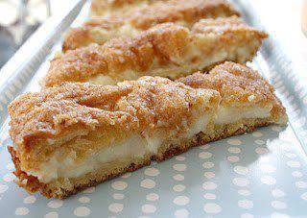
Found this recipe and it had no name...
I only know it should be illegal!!!
Ingredients:
-2 cans Pillsbury butter crescent rolls
-2 (8oz) packages cream cheese (softened)
-1 cup sugar
-1 teaspoon vanilla
-1/4 cup butter (melted)
-Cinnamon & sugar (I used about 1/4 cup sugar and 1 tbs cinnamon)
Instructions:
Unroll and spread 1 can crescent rolls on bottom of un-greased pan. Combine softened cream cheese, sugar, and vanilla. Spread mixture over crescent rolls. Unroll and spread remaining crescent rolls over mixture. Spread melted butter over the top and sprinkle with cinnamon and sugar. Bake at 350 degrees for 20-30 minutes.

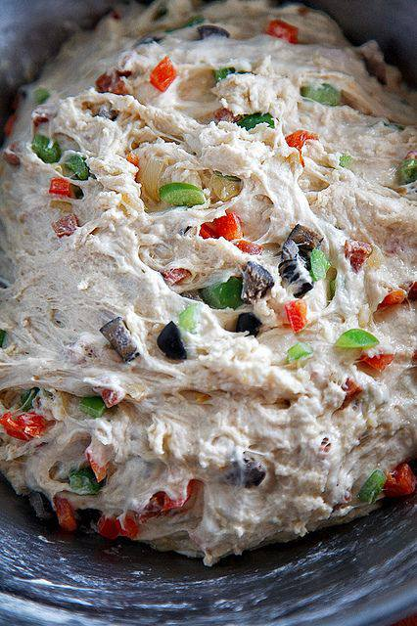
Crazy Pizza Bread
Serves 4 to 6
Use your favorite pizza toppings for this. I used red bell peppers, green peppers and pepperoni to keep it kid-friendly. Other suggested add-ins: caramelized onions and roasted garlic (dry roast unpeeled cloves on a skillet for about 5 minutes, then finely mince or mash into a paste). If using a topping that will render fat, microwave it for a minute or two to prevent the fat from rendering into the dough while baking, which will alter the texture of the bread. Serve with a simple marinara sauce or tomato soup for dipping.
Ingredients:
1 teaspoon yeast
3/4 cup warm water
1 2/3 cups all-purpose flour
1 teaspoon kosher salt
1/2 cup Ripe Olives or 1/2 cup Black Ripe Olives, sliced (optional)
1 1/2 cups favorite toppings, chopped
8 oz. shredded mozzarella cheese
1 tablespoon olive oil
Sprinkle yeast over warm water in a bowl. Let it sit for 3 minutes until foamy, then add in flour and salt. Mix (using a mixer, spoon, or your hands) just until it comes together. Add in the olives and toppings and combine well. Dough will be tacky, but feel free to dust with a bit more extra flour if it feels too tacky. Let rise for about 1 hour, then put in the refrigerator for another hour.
Take the dough out of the refrigerator and flour a Silpat or waxed paper. Roll out into a rectangle about 11×17”. Sprinkle cheese over top. Then, using the Silpat or paper, fold along the long side, like an envelope. Seal sides so cheese is not exposed. Let rest while you preheat oven to 450 degrees. Let oven stay at 450 degrees for 20 minutes.
Bake the bread, either on a pizza stone or baking sheet, for 25 to 30 minutes, until golden brown. About 3 minutes before taking it out, lightly brush the top with olive oil and let it finish baking. Let rest on a wire rack to cool slightly before slicing.
To pack for lunch, wrap slices in foil and lightly toast before putting it in a lunchbox. Include a small container of tomato soup or marinara sauce for dipping.

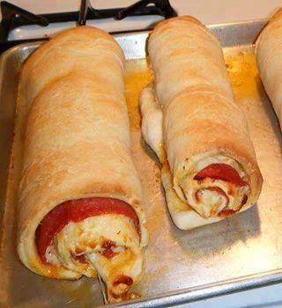
Cheesy Pepperoni Twist Rolls Recipe
Ingredients:
Frozen bread dough
Pepperoni
Mozzarella cheese
Parmesan cheese
Olive oil
Italian seasoning
1/4 cup tomato sauce (Optional)
8 slices bacon
1 small to medium onion if desired diced finely
Directions:
Loosely cover the frozen bread dough with plastic wrap. Allow the dough to thaw for a few hours at room temperature. When the dough is completely thawed it will be slightly puffed up.
Here's a tip: Spray the plastic wrap with cooking oil, or brush it with cooking oil and lay it, oiled side down on the bread dough. This allows the bread dough to rise and move easily under the plastic wrap without it sticking or holding back the dough. cook and crumble bacon
Roll dough out to an approximately 11 x 11 inch square. One frozen dough log makes one pepperoni roll.
Brush dough with olive oil or whatever cooking oil you prefer. Lay pepperoni on the dough covering entire surface. Sprinkle with shredded mozzarella cheese.
Next, sprinkle it with shredded Parmesan cheese and lightly sprinkle it with Italian seasoning. Add a sprinkling of garlic salt (optional).and add crumbled bacon and finely diced onion if so desired
Roll up the dough starting at one edge of the square.
Place rolls on baking sheet, leaving space between them if you are making more than one roll. Brush some melted butter on top of the uncooked pepperoni roll(s).
Bake at 375 degrees F for approximately 15 to 25 minutes. Oven temperatures and times may vary. When done, the top of the rolls should be golden brown and you should be able to make a tapping sound on the crust with your fingernail (the same as when baking bread).

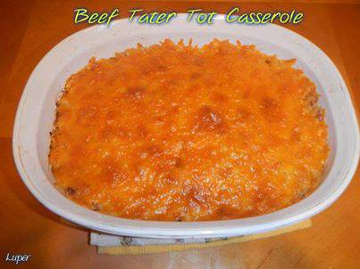
Beef Tater Tot Casserole
Ingredients
Ground Beef – Lean 1 lb.
¼ cup Sweet Baby Rays BBQ Sauce
½ cup Chopped Onion
2 slightly beaten Eggs
1/3 cup Seasoned Dry Bread Crumbs
1 Tbsp. Chili Powder
¾ tsp salt
16 oz. bag Frozen Ore-Ida Tater Tots
2 Tbsp. Butter
1 tsp. Garlic Powder
6 oz. Canned Evaporated Milk
8 slices Bacon – crumbled
½ cup Canned Crispy Fried Onions
8 oz. Shredded Cheddar Cheese

Preheat oven to 375 degrees. Lightly grease a 9x9 baking pan. Mix together your beef, bbq sauce, onion, eggs, bread crumbs, chili powder & salt in a large bowl. Mix well. Gently press into bottom of your baking pan. Bake uncovered approximately 25 minutes or until cooked thoroughly. Carefully remove from oven and drain off any excess grease. Change oven temperature to Broil and move oven rack 6-8 inches from heat source.
While you are waiting on the meat to cook go ahead and put your frozen tater tots in the Microwave until softened. Time varies with microwave power. In a large bowl mix together the tater tots, milk, butter and garlic with a potato masher or fork. Stir in the Bacon and Fried Onions. Spread evenly over beef. Top with cheese. Broil 3 to 5 minutes or until cheese is lightly browned. Serve hot with additional barbeque sauce if desired.
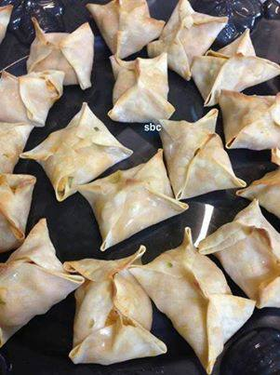
Buffalo Chicken Wontons
Ingredients:
2 shredded chicken breasts (you can use left over chicken, or rotisserie)
1/2 -3/4 cup hot sauce or favorite wing sauce
1/4 cup diced scallions
1 package of wonton wrappers
Your favorite blue cheese or ranch dip/dressing
Olive Oil for brushing
water for sealing
Directions:
Preheat oven to 350.
In a bowl with fork or your clean fingers shred your chicken. Toss with scallions and sauce. Set aside
To assemble, brush the sides of your wontons wrappers with water. Place a tbs of chicken filling in the center.
Raise all four corners together and pinch and seal shut.
Brush each finished wanton with oil.
Bake for about 15 minutes or until wontons are golden brown.

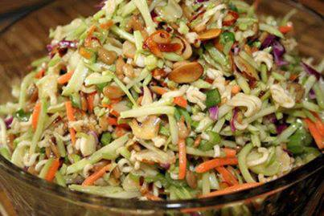
Oriental Ramen Broccoli Cole Slaw
2 (3 ounce) packages beef-flavor ramen noodles
2 (8 1/2 ounce) packages broccoli coleslaw mix
1 cup toasted slivered almonds
1 cup sunflower seed
1/2 bunch green onion, chopped
1/2 cup sugar
3/4 cup oil
1/3 cup white vinegar
Directions:
1. Before opening noodles, crush into 1 inch pieces. Open packages and set aside flavor packets.
2. Place noodles in bottom of large serving bowl. Top noodles with broccoli slaw, then sprinkle with almonds and sunflower kernels, and green onions.
3. In a separate bowl combine sugar, oil, vinegar, and flavor packets from noodles. Pour over slaw, cover and chill up to 24 hours.
4. Toss before serving.

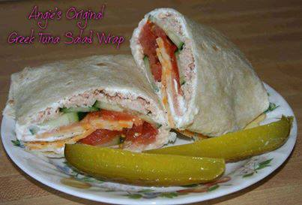
Angie's Greek Tuna Salad Wrap
Ingredients:
1 tortilla
1/8-1/4 cup of plain Greek Yogurt
1 3oz can Tuna (packed in water)
Cucumber sliced thin
Tomato sliced thin
Cheese (I used Colby Jack, thinly sliced)
Pepper to taste
Smear Greek Yogurt on a tortilla. Drain tuna and flake on to the yogurt. Add sliced cucumber (or pickles). Top with thinly sliced tomatoes. Add slice of your favorite cheese if desired. Sprinkle with pepper or garlic or whatever your go-to condiment is. Fold bottom of tortilla up about 1/4 of the way. Fold right side & left side over. Roll and flip to make a fat wrap.
Calories: 370
Protein: 31.5 grams
Carbs: 30 (total, not net)
Fat: 15 grams

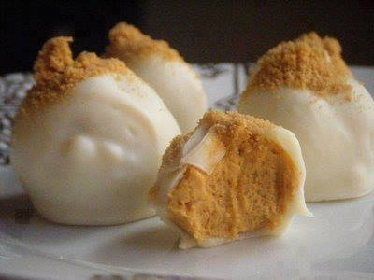
Pumpkin Cream Cheese Truffles
Yield: Approximately 30, depending on how large or small you roll them.
Ingredients:
½ cup white chocolate chunks or chips
2 cups white chocolate almond bark (I think I used around 4-5 cubes)
1/3 cup gingersnap cookie crumbs, plus more for garnish
1/4 cup canned pumpkin purée
1/4 cup graham cracker crumbs, plus more for garnish
1 tablespoon confectioners’ sugar
1/2 teaspoon orange zest
1/8 teaspoon ground cinnamon
Pinch of fine salt
2 ounces cream cheese, softened
Directions:
Melt the 1/2 cup of white chocolate chips in a double boiler over medium-low heat or in the microwave for about 1 minutes. Stir often to keep the chocolate from burning. Transfer to a large bowl. Add gingersnap crumbs, pumpkin, graham cracker crumbs, sugar, zest, cinnamon, salt and cream cheese and beat with an electric mixer until smooth. Transfer to a shallow bowl, cover and chill until just solid enough to roll into balls, about 2 hours.
Line a large sheet tray with parchment paper. Melt remaining 2 cups white chocolate almond bark and transfer to a small, deep bowl. Roll 1 heaping teaspoon of the pumpkin mixture into a ball in your hands, then drop into the chocolate. Working quickly, gently spoon chocolate over to coat. Using a small spoon or fork, lift the truffle out of the chocolate, shake off excess and transfer to prepared sheet tray. Dollop a bit of extra chocolate on any parts that remain exposed, then sprinkle a few gingersnap or graham cracker crumbs over the top, if you like.
Repeat process with remaining pumpkin mixture and chocolate, then chill truffles until chocolate is completely set, about 1 hour.
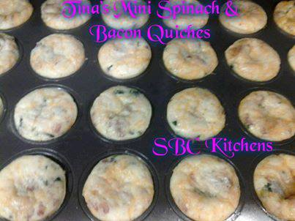
~Tina's Mini Spinach and Bacon Quiches~
Ingredients:
1 teaspoon olive oil
1 teaspoon butter
1/2 onion, chopped
1 clove of garlic finely chopped
1 (7-ounce) container baby spinach or 1 box of frozen spinach, squeezed dry
6 large eggs
3 oz reduced fat cream cheese
1/4 cup lowfat cottage cheese
1/2 cup low-fat (1%) milk
1/2 cup heavy cream
1/2 teaspoon salt
1/2 teaspoon black pepper
1/2 teaspoon garlic powder
1/8 teaspoon cayenne
Pinch nutmeg
1/2 to 1 cup reduced-fat shredded Swiss cheese
6 slices bacon, cooked and crumbled (about 4 tablespoons)
Instructions:
Preheat the oven to 375°F. Spray a mini muffin pan with nonstick spray.
Heat the oil & butter in a large nonstick skillet over medium-high heat. Add the onion and garlic cook, stirring occasionally, until tender, about 5 minutes. Add the spinach and cook, stirring, until the spinach is wilted and any liquid is evaporated, 2 – 3 minutes.
Blend 3 oz of lowfat cream cheese & 1/4 cup lowfat cottage cheese until smooth, add 1/2 cup lowfat milk & 1/2 cup heavy cream, salt & pepper, garlic powder, cayenne, and nutmeg. Whisk the eggs in a large bowl until lightly beaten, add to milk/cheese mixture & whisk until well blended. Stir in the spinach mixture, swiss cheese, and bacon until well combined.
Spoon into mini muffin tins (about 2 tablespoons in each). Bake until the tops are slightly golden and a toothpick inserted into the center comes out clean, about 15 minutes. Let stand 5-10 minutes before serving. Enjoy!!!
Note: You can also make this recipe in a 9 inch pie plate. If you opt to do this, bake at 375°F for 35-40 minutes & let cool for 10 minutes before slicing.
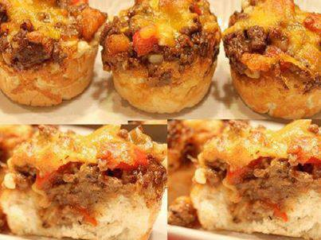
BBQ Biscuit Pie
Biscuits:
2 cups flour
1 Tbsp. Baking Powder
¼ cup soft butter
¾ cup milk
Preheat oven to 350 degrees F.
Blend flour, baking powder and butter until crumbly. Add milk. Roll out biscuits and place in bottle of a greased 9x13 baking dish.
Filling:
A little bit of oil for frying
1 lb ground Venison (or hamburger)
1 small onion, diced
1 small red bell pepper, diced
Salt and pepper to taste
About a cup of BBQ sauce, see below
2 Cups cheddar Cheese, shredded
Brown ground venison, bell pepper and onion in oil. Season to taste. Stir in BBQ sauce until mixtures is evenly covered or to taste. Pour venison mixture over biscuits. Sprinkle cheddar cheese on top liberally. Bake about 15 minutes or so until cheese is melted and lightly brown on top.
Variation: divide biscuits into 12 portions and place each in a greased muffin tins. Spoon filling equally into each muffin tin over biscuits, and top with cheese.
BBQ Sauce: Whisk together:
2/3 cup ketchup
1 tsp mustard
2 ½ Tbsp Worcestershire sauce
2 Tbsp cider vinegar
¼ cup brown sugar, packed
dash garlic
¼ tsp each salt, crushed red pepper, black pepper
¼ cup olive oil
Whisk all together.
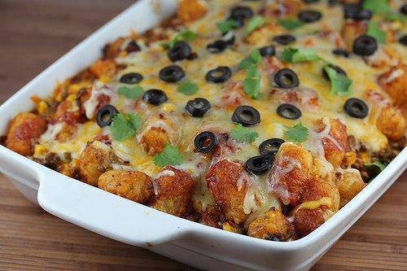
TATOR TOT TACO BAKE
1 lb ground beef
1 small onion (diced)
1 garlic clove (minced)
1 small can black olives (sliced)
1 (1 ounce) package taco seasoning mix
1 (16 ounce) bag frozen corn
1 (4 ounce) can green chilies (diced and drained)
1 (12 ounce) can black beans (drained and rinsed)
1 (16 ounce) bag shredded Mexican cheese blend
1 (16 ounce) package frozen tater tots
1 (10.5 ounce fluid ounce) can enchilada sauce
Preheat the oven to 375 degrees. Spray a 9×13 inch baking dish with cooking spray. Heat a skillet to medium high heat. Add ground beef, garlic, and onion and cook while breaking the meat apart with a spoon or spatula until the ground beef is completely browned. Drain off any excess fat. Add taco seasoning mix, green chilies, frozen corn, and black beans to the ground beef. Cook until heated through.
In a large bowl combine ground beef mixture, ¾ of the Mexican cheese blend, and all of the tater tots. Stir well to combine.
Pour about 1/3 of the enchilada sauce into the bottom of the prepared baking dish. Add the tater tot mixture to the baking dish and lightly pat the mixture down into a solid, even layer. Pour the remaining enchilada sauce over the tater tots.
Place into the oven and bake at 375 degrees for 40 minutes. During the last few minutes of baking, top the casserole with the remaining Mexican cheese blend and the sliced black olives. Return to the oven and bake until the cheese is melted and bubbly.

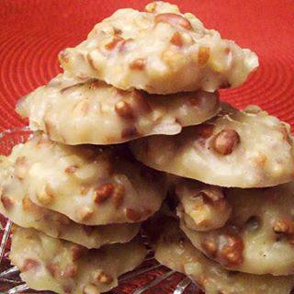
No Bake - Pecan Coconut Praline Cookies
2½ cups sugar
½ cup evaporated milk
½ cup corn syrup
½ cup butter
1 teaspoon vanilla
2-2½ cups chopped pecans
2½ cups grated coconut
1. Set pecans, coconut, and vanilla off to the side
2. Mix sugar, evap milk, corn syrup, and butter in large saucepan.
3. Bring to a rolling boil & boil for 3 minutes.
4. Remove from heat & add pecans, coconut, and vanilla
5. Stir for about 4 minutes.
6. Take a spoonful of batter and place on wax paper. Let it sit until batter has
hardened.
7. Remove from paper and enjoy.

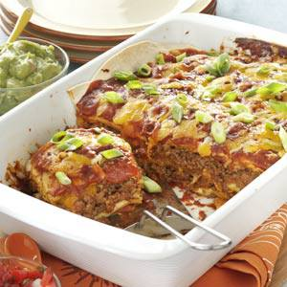
Pan Burritos
2 packages (1-1/2 ounces each) enchilada sauce mix
3 cups water
1 can (12 ounces) tomato paste
1 garlic clove, minced
1/4 teaspoon pepper
Salt to taste
2 pounds ground beef
9 large flour tortillas (9-inch)
4 cups (16 ounces) shredded cheddar cheese or Mexican cheese blend
1 can (16 ounces) refried beans, warmed
Taco sauce, sour cream, chili peppers, chopped onion and/or guacamole, optional
Directions
In a saucepan, combine the first six ingredients; simmer for 15-20
minutes.
In a skillet, brown the beef. Drain; stir in one third of the sauce.
Spread another third on the bottom of a greased 13-in. x 9-in.
baking pan.
Place three tortillas over sauce, tearing to fit bottom of pan. Spoon
half of the meat mixture over tortillas; sprinkle with 1-1/2 cups
cheese. Add three more tortillas. Spread refried beans over
tortillas; top with remaining meat. Sprinkle with 1-1/2 cups of cheese. Layer remaining tortillas; top with the remaining sauce.
Sprinkle with remaining cheese.
Bake, uncovered, at 350° for 35-40 minutes. Let stand 10 minutes
before cutting. Serve with taco sauce, sour cream, chili peppers,
chopped onion, and/or guacamole if desired. Yield: 8-10 servings.

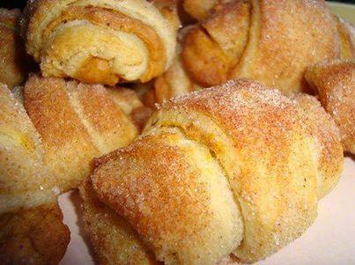
MINI FALL PUMPKIN PIE CROISSANTS
These start with 2 tubes of Pillsbury refrigerated crescent rolls. Roll each crescent roll out and cut lengthwise in 2. This recipe will make 32 mini croissants. Each croissant will get a generous teaspoon of this luscious cream cheese pumpkin pie filling:
4 oz. (1/2 block) of softened cream cheese
1 cup of canned pumpkin (not pumpkin pie filling)
1 – 2 Tablespoons pumpkin pie spice (adjust to taste)
3 – 4 Tablespoons sugar (granulated or powdered; adjust to taste if you want the filling sweeter)
Step 1. Beat the above ingredients together until fluffy and creamy and spread about one teaspoon of filling over each triangle of dough.
Step 2. Mix together 4 Tablespoon sugar and 1 Tablespoon pumpkin pie spice and roll each pumpkin pie croissant in it! Bake at 375* for about 13-15 minutes (this time is for on a baking stone) – you want them to be lightly browned and the dough baked through. Please keep negative comments to yourself. ALTER AT YOUR OWN RISK.

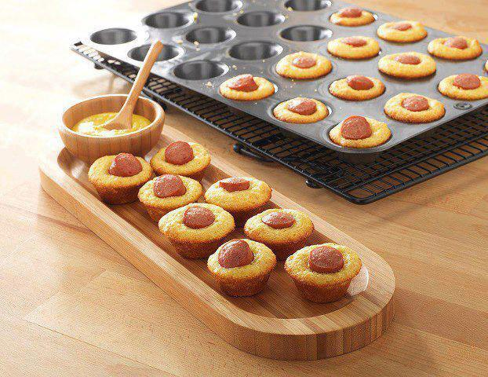
MINI CORN DOG BITES
How fun to make this with your kids.....or to just bring out the kid in you!!
Click SHARE to SAVE to your wall!
Mix up an 8.5oz box of corn muffin mix, divide batter into the Mini-Muffin Pan, and add hot dog slices. Bake for 10-12 minutes at 375°. Enjoy this fun way to serve corn dogs with "flair!"

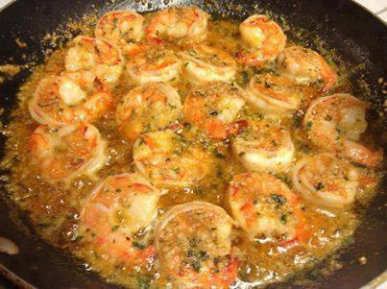
Famous Red Lobster Shrimp Scampi
1 lb medium shrimp, peeled and deveined
1 tablespoon pure olive oil
... 2 tablespoons garlic, finely chopped
1 1/2 cups white wine, I use chardonnay
1/2 fresh lemon, Juice only
1 teaspoon italian seasoning
1/2 cup softened butter
1 tablespoon parsley
1/2 cup grated parmesan cheese
Directions:
1 Heat cast iron skillet and add olive oil.
2 Add shrimp and cook until tender and no longer translucent, reduce heat. Remove Shrimp and set aside.
3 Add garlic and cook 2-3 minutes. Do not allow garlic to brown - it will make it bitter.
4 Add white wine, and lemon juice.
5 Cook until wine is reduced by half. After it is reduced, add Italian seasoning.
6 Reduce heat to low, and add butter. If pan is too hot, the butter will separate.
7 Add shrimp back into sauce, add parsley, and season to taste with salt and pepper.
8 Sprinkle with grated Parmesan Cheese

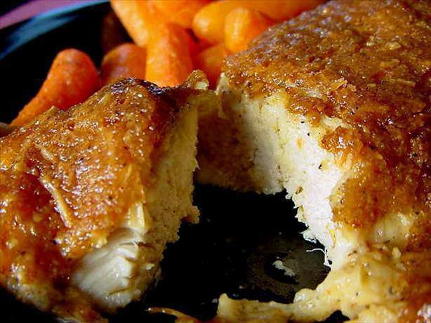
MELT IN YOUR MOUTH CHICKEN
And it's Healthy...So much better than fried!!!
1/2 cup parmesan cheese
1 cup Greek yogurt -plain
1 tsp garlic powder
1 1/2 tsp seasoning salt
1/2 tsp pepper
Spread mixture over chicken breasts, bake at 375 degrees for 45 mins--Absolutely Delish!

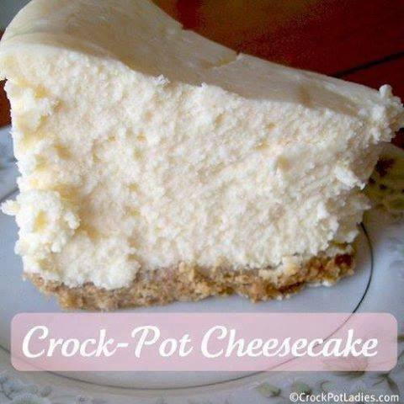
Crock-Pot Cheesecake
Ingredients
3 8oz Packages of Philadelphia Cream Cheese
3 Eggs
3/4 Cup Sugar
6 Graham Crackers (full pieces), pulverized into crumbs
3 Tablespoons of Stick Butter, melted

Instructions
Allow Cream Cheese to get to room temperature.
Open cream cheese and place in large bowl.
Add Sugar.
Mix until sugar and cream cheese are well blended.
Add the 3 eggs one at a time. After adding an egg, blend, then add the other etc.
In a separate bowl, add graham cracker crumbs and melted butter.
Mix well as this will form your crust.
Choose a pan or small crock type cooking pan that will fit in the bottom of your crock-pot with room left on the side. You want to be able to pull the pan out without too much difficulty.
Add the graham cracker crumbs mixture to the bottom of the pan.
With a spoon, pat the graham crackers out til you have a smooth layer.
Add the cream cheese mixture to the top of the graham crackers.
Add 2 to 3 cups water to the bottom of the crock-pot. You need enough to last 2 hours but not too much that it will get in your pan.
Place the cheesecake pan in the crock-pot and place the lid of the crock-pot on.
Cook on high for 2 hours to 2 hours and 30 minutes or until the center does not have a watery consistency when you stick a knife into it.
The cheesecake will begin to crack on the sides.
Let cool for 30m to 1h.
Remove and let set in the refrigerator for at least 1 hour.
Serve.

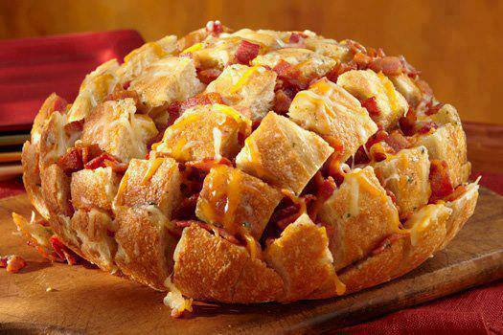
Bacon Cheddar Pull-Apart Bread
8 oz of your favorite shredded cheddar cheese blend.
1 large round loaf of soft bread (like a French or Italian round)
8 oz. diced sliced bacon, cooked crisp
1/2 cup melted butter
1 Tablespoon dry Ranch dressing mix from packet
Cut bread in 3/4-inch intervals, being careful to not cut all the way through. Cut again, crosswise, not cutting all the way through. Place cheese in between all cuts: sprinkle with bacon. Blend melted butter and Ranch mix and drizzle over top of bread evenly. Wrap in foil and bake at 350 degrees for 15 minutes; uncover and bake 10 minutes more. Serve hot and pull apart pieces from loaf to eat!

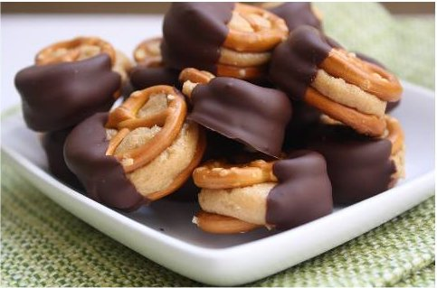
Pretzel Sandwich Cookie
Ingredients
1 Cup Creamy Peanut Butter
2 Tbsp Softened Butter
1/2 Cup Powdered Sugar (Maybe More)
3/4 Cup Brown Sugar (Maybe More)
Pretzels
1 Bag Semi-Sweet Chocolate Chips

Directions:
Combine peanut butter and softened butter in a large bowl with a fork or whisk, or in a stand mixer. Add the sugars and mix to combine. At this point if the filling will roll easily into balls without sticking to your hands you're ready to go. If not, add a little more of each sugar until you reach a consistency that is easy to roll. ( I used about 3/4 Cup of each sugar.)
Use a teaspoon measure to scoop the filling. Roll each portion into a small ball, then sandwich them between two whole pretzels. When all the balls are rolled and successfully sandwiched, stick the whole tray into the freezer for about a half an hour.
Pour the chocolate chips into a microwave safe bowl and heat at 30 second intervals, stirring occasionally until completely melted. Remove the pretzel sandiches from the freezer and quickly dip each half-way into the melted chocolate. Return to the tray and repeat with remaining sandwiches. When all are dipped, return the tray to the freezer to set up completely. Store the sandwiches in the refrigerator until serving time.
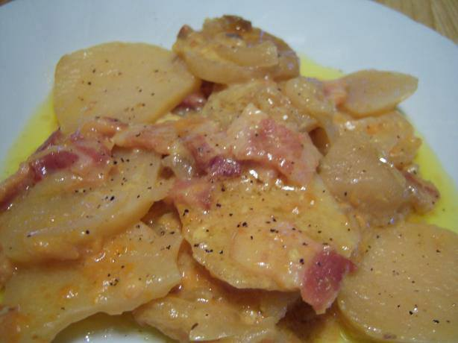
Crock Pot Scalloped Potatoes
6 large potatoes, sliced
1 small onion, diced
8 slices bacon, uncooked diced
2 cups shredded cheddar cheese
1 (10 1/2 ounce) can cream of chicken soup
Place half of the sliced potatoes in bottom of crock pot.
Top with half of the onions cheese and bacon.
Repeat layers in order.
Top with cream of chicken soup.
Cook on low for 8 to 10 hours.

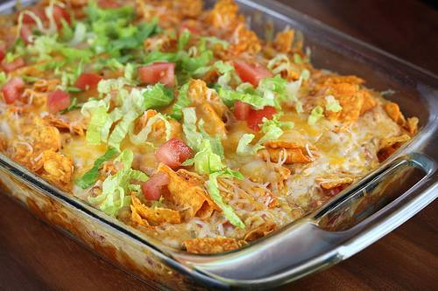
Cheese Doritos Chicken Taco Casserole
Ingredients:
2 cups shredded cooked chicken
2 cups shredded Mexican cheese blend (divided)
1 (10 oz) can cream of chicken soup
½ cup milk
½ cup sour cream
1 can Ro-tel tomatoes (drained)
½ packet taco seasoning
1 large bag Doritos
Shredded lettuce (optional)
diced tomato (optional)
Cooking Instructions:
Step 1: Pre-heat the oven to 350 degrees. In a large bowl mix together shredded chicken, 1 cup of cheese, cream of chicken soup, milk, sour cream, Ro-tel tomatoes, and taco seasoning. Mix well.
Step 2: Grease a 2-quart casserole dish, and add a layer of crushed Doritos across the bottom. Top with a layer of the chicken mixture. Add another layer of crushed Doritos, and then add another layer of the chicken mixture. Top with remaining cheese. You can add more crushed Doritos on top as well if you wish.
Step 3: Cover and place into the oven and bake at 350 degrees for 30-25 minutes until bubbling hot. Remove from the oven and top with lettuce and tomato if you choose.

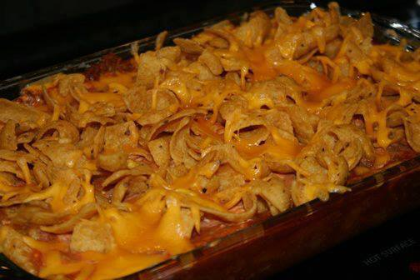
Oven-Baked Frito Pie
Ingredients:
1 lb. lean ground beef
1 can (16 oz) chili beans
1 can (8 oz) tomato sauce
1 can (15 oz) diced tomatoes
1 envelope low sodium taco seasoning
1 cup shredded cheddar cheese (2% fat kind)
3 1/2 cups corn chips (Fritos)
1 1/4 cup fat free sour cream
Directions:
Cook ground beef until meat is browned; drain. Stir in beans, tomato sauce, diced tomatoes, taco seasoning mix and 1/4 c. of cheese. Sprinkle 1 cup corn chips in bottom of 8x8 baking dish. Cover with chili. Bake at 350 for 20 minutes. Spread sour cream over chili. Top with remaining corn chips and cheese. Bake 4-5 minutes longer.

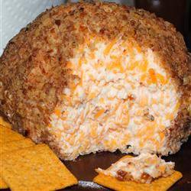
Buttermilk Ranch Cheeseball
"This is the quickest and easiest appetizer I know of. It takes only minutes to make and can be served almost immediately. You can keep the ingredients on hand for months. Serve with buttery crackers."
Ingredients
1 tablespoon sour cream
1 (1 ounce) package ranch dressing mix (such as Hidden Valley Ranch ®)
1 (8 ounce) package cream cheese
1/2 pound Cheddar cheese, shredded
1/4 cup finely chopped pecans
Directions
Mix the sour cream with ranch dressing mix in a bowl until smoothly combined. Add the cream cheese and Cheddar cheese to the bowl, and mix together with your hands until thoroughly blended. Chill the mixture for 5 minutes, then shape into a ball.
Place the pecans into a shallow bowl, and roll all sides of the cheese ball in the pecans to coat. Serve immediately.

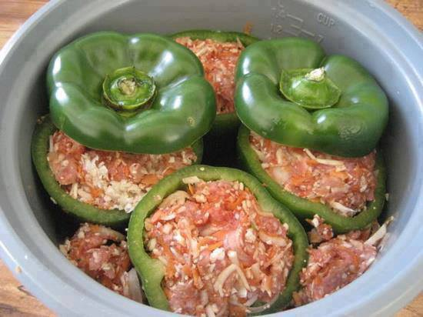
Stuffed peppers
2 pounds ground turkey (or a combination of turkey and beef)
4 large green peppers
1 large onion
2 carrots
4 cloves of garlic
1/2 head of cauliflower
6 ounce can of tomato paste
1 tablespoon dry oregano
1 tablespoon dry or fresh tarragon
Salt and pepper to taste
Instructions:
Cut the tops of the peppers and clean the seeds out.
Arrange peppers in the Crock-Pot standing up and make sure they fit securely.
Grate onion, carrots, garlic and cauliflower in the food processor. You can also just chop them into small pieces with a knife if you don’t have a food processor.
In a big bowl, combine ground turkey, shredded vegetables, seasonings and tomato paste.
Add salt and pepper to taste. Stuff the peppers with the mixture and arrange leftover meat between the peppers. Add half a cup of water, cover and cook on low for 8-10 hours.
If you don’t have a slow-cooker, the dish can be cooked in the oven, covered, for 1-2 hours.
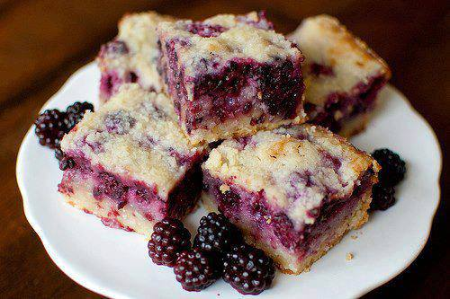
"Blackberry Pie Bars"
Be sure to save this by clicking "SHARE"! You will be able to find it on your own timeline later! Also, you can "follow" my public profile to keep up with new recipes I post.
Ingredients:
Crust and Topping
3 cups all-purpose flour
1 1/2 cups sugar
1/4 tsp salt
1 1/2 cups (3 sticks) unsalted butter, chilled
Fruit Filling:
4 large eggs
2 cups sugar
1 cup sour cream
3/4 cup flour
pinch salt
zest of 1/2 lemon
1 tsp almond extract
2 (16-oz) packages frozen blackberries, thawed and drained
Directions:
To make the crust and topping, preheat the oven to 350 degrees. Grease a 9X13 inch baking pan.
Combine the flour, sugar, and salt in the bowl of a food processor. Pulse a few times to mix. Cut the butter into 1/2-inch cubes, and add to the flour mixture. Process until the butter is evenly distributed but the mixture is still crumbly, 30-60 seconds.
Reserve 1 1/2 cups of the mixture to use as the topping. Press the remaining mixture into the bottom of the pan, and bake 12-15 minutes. Cool for at least 10 minutes.
To make the filling, whisk the eggs in a large bowl, then add the sugar, sour cream, flour, salt, lemon zest, and almond extract. Gently fold in the berries and spoon the mixture over the crust. Sprinkle the remaining flour mixture evenly over the filling, and bake 45 to 55 minutes.
Cool at least 1 hour before cutting into bars, or scoop out of the pan to serve cobbler-style.

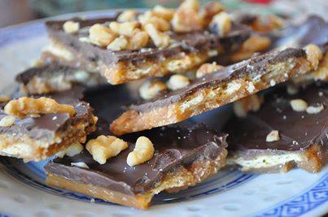
Fool's Toffee
(I love this stuff! Its so easy and yummy! I always make it!)
36 saltine crackers
1 cup butter
1 cup brown sugar
1 (12 ounce) package chocolate or white chocolate chips
1 cup of your choice of chopped walnuts, peanuts, sprinkles, crushed candy, etc...
Directions:
1 Line a cookie sheet with aluminum foil and spray with non stick cooking spray.
2 Place the saltines side by side but not over lapping each other.
3 In a sauce pan melt the 1 cup of butter and add the cup of brown sugar bring to a slow boil stirring constantly for about 3 minutes.
4 Immediately pour over the crackers try to coat as evenly as possible.
5 Bake in the oven at 375°F for 5-7 minutes immediately remove from oven and pour the entire bag of chips over the toffee (give them some time to melt) and spread evenly with a spatula. Sprinkle your choice of topping over the candy and press down lightly.
6 Refrigerate till cool then remove and break into pieces and serve!
(Crushed peppermint with white chocolate chips are awesome during Christmas

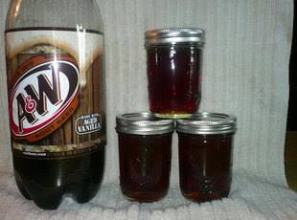
Root Beer Jelly
Ingredients
2 c root beer,soda
6 c sugar
1 c water
1 bottle liquid fruit pectin
Directions
1. Combine all ingrdients except pectin heat to boiling stirring to dissolve sugar.Add pectin stirring constantly.Bring to a boil and boil hard for 30 seconds skim ladle into hot jelly jars.Process 5 mins.water bath canner
2. Can use other flavors of soda.

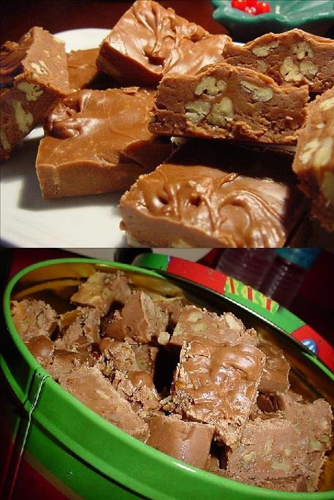
Paula Dean's Delicious 5 Minute Fudge
Ingredients:
1 2/3 cups white sugar
2/3 cup evaporated milk
1 tablespoon unsalted butter
1/2 teaspoon salt
1 (6 ounce) packages milk chocolate chips
16 large marshmallows
1 teaspoon pure vanilla extract
1 cup chopped nuts
Direction:
Combine sugar, milk, butter and salt in a medium sized saucepan. Bring to a boil, cook 5 minutes, stirring constantly.
Add in chocolate chips; cook until melted.
Remove from heat; stir in marshmallows, vanilla and nuts. Mix well.
Pour into a 8-inch pan.
Cool and cut into equal pieces ..Enjoy!

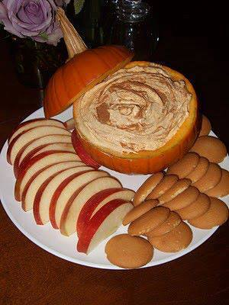
FALL DIP
{Cool Whip, vanilla pudding mix, and a can of pumpkin}
I make this every year. You use 16 oz of cool whip, 3 small boxes instant vanilla pudding *** dry mix only*** DON'T make the pudding*** , one small can of pumpkin. Mix everything together and then add some pumpkin pie spice. Serve with graham crackers. SOOO soooo good!!!

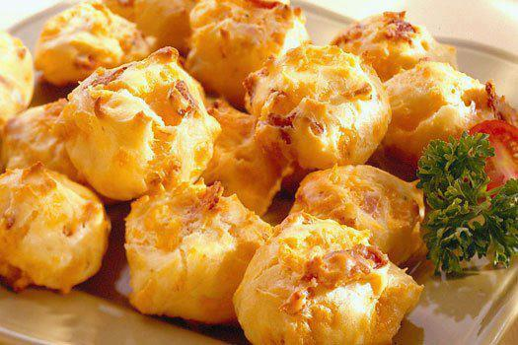
Bacon Cheddar Puffs
oh I so love these! Light an fluffy ...like air with bacon!
1 cup milk
1/4 cup butter
1 cup all-purpose flour
4 large eggs
1 cup Sargento Fine Shredded Sharp or Mild Cheddar Cheese
8 slices bacon, cooked crisp, crumbled
1/2 tsp. onion salt or powder
1/4 teaspoon garlic salt
1/4 teaspoon pepper
Combine milk and butter in medium saucepan. Heat over medium heat until butter is melted and mixture is simmering. Add flour all at once; continue to cook, stirring vigorously with a wooden spoon, until mixture forms a ball. Remove from heat.
Beat in 1 egg until mixture is smooth. Repeat with remaining eggs, adding just 1 egg at a time, beating until thoroughly combined. Stir in remaining ingredients.
Drop heaping teaspoons of mixture onto greased baking sheet. Bake in preheated 350°F oven 25 minutes or until puffed and golden brown. Serve warm or at room temperature.

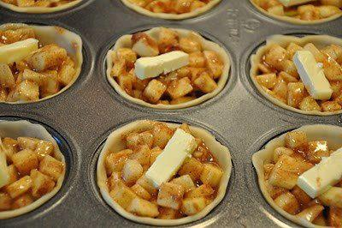
Mini Apple Pie’s

Start by cutting up eight cups of apples into small 1/2in bits.
Mix the apples with:
12 tablespoons of flour
1 1/2c of sugar
4 heaping teaspoons of cinnamon
1/4-1/2 teaspoon of nutmeg (depending on how much you like nutmeg...you could also leave it out)
You will also need:
4 tablespoons of chilled butter cut into 24 equal portions.
two boxes of pillsbury pie crusts (four chilled NOT frozen crusts)
Unroll your first pie crust and cut several circles out. Continue this until you have enough crusts.
I found that a wide mouth mason jar ring worked perfectly.
Line each cup of your muffin tin with a tiny pie crust.
gently fill the crusts with your apple mixture
You should be able to fill until slightly mounded.
and put a dab of butter on each pie.
Cover as desired with left over dough. Brush with melted butter and bake at 400 for 18 to 22 minutes.
recipe makes 24 mini pies

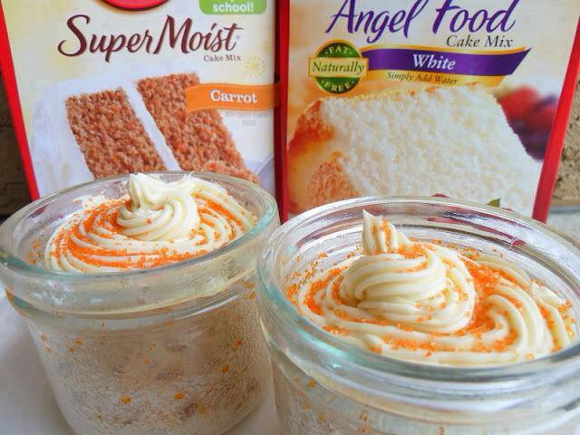
3, 2, 1 CAKE!!
1 box angel food cake mix
1 box cake mix, any flavor
Mix two cake mixes together, and store in large ziplock bag.
These individual little cakes are amazing and ready to eat in one minute!
They are perfect for whenever you feel like a treat without all the fat and calories that cake can have.
This recipe is called 3, 2, 1 Cake because all you need to remember is:
3 tablespoons mix,
2 tablespoons water,
1 minute in the microwave!

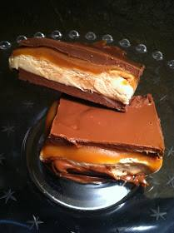
Billion Dollar Bar
The gentleman who gave me this recipe told me he’d been making candy for over 45 years and this was the Billion Dollar Bar as far as he was concerned. He’d made divinity, all sorts of fudge, tempered chocolate, spun sugar, and pulled taffy, but this is his favorite.
Bottom Chocolate Layer
1 cup milk chocolate chips (or half semi-sweet)
1/3 cup butterscotch chips
1/3 cup peanut butter
Melt milk chocolate chips, butterscotch chips and peanut butter in a pan over low heat; stirring constantly. Pour mixture into a 9 x 13″ baking pan lightly coated with nonstick spray or lined with plastic wrap which is long enough to drape over sides of the pan. Spread mixture and place in the refrigerator for 30 minutes.
Nougat Layer
4 tablespoons butter
3/4 cup sugar
1/4 cup light brown sugar
1/4 cup evaporated milk
1-1/2 cups marshmallow creme
1/3 cup peanut butter
1-1/2 cups chopped salted peanuts (optional)
Melt butter over medium heat in pan; add sugars and evaporated milk; bring to a boil, and cook additional 5 minutes while stirring. Remove from the heat and add marshmallow creme and peanut butter. Pour over the bottom layer and gently spread mixture. If you use peanuts, scatter across the top. Place in the refrigerator for 15 - 30 minutes.
Caramel Layer
1 (14-ounce package) caramel candy
1/4 cup cream
1 tablespoon butter
Place the unwrapped caramel candy, butter, and cream in a medium saucepan. Place over low heat and stir until the mixture has completely melted and is smooth. Pour in the pan and quickly spread over nougat layer. Place in the refrigerator for 15 - 30 minutes.
Top Chocolate Layer
1 cup milk chocolate chips (or half semi-sweet)
1/3 cup butterscotch chips
1/3 cup creamy peanut butter
Melt milk chocolate chips, butterscotch chips, and peanut butter in a pan over low heat, stirring consistently. Pour over the caramel layer and spread. Place in the refrigerator for at least 1 hour before cutting into squares. Store in an air-tight container.
NOTE: I have substituted peanut butter chips for the butterscotch chip in one or both layers. Even though you can't see the peanuts, they are in this batch.

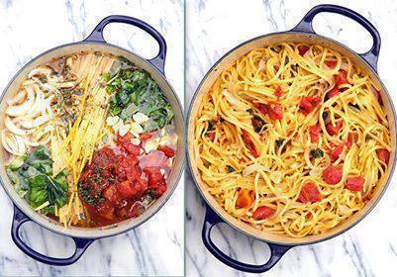
Tomato Basil Pasta!
Pasta, Tomatoes, Veggie Broth, Olive Oil, and Seasonings (details below)
Throw it all in the pot, INCLUDING the uncooked Pasta, and cook! - Bring it to a boil, then reduce to a simmer. The starch leaches out of the pasta and makes a rich, warm sauce for the noodles. The other ingredients cook right along with the pasta
Ingredients
12 ounces pasta (I used Linguine)
1 can (15 ounces) diced tomatoes with liquid ( I used zesty red pepper flavor)
1 large sweet onion, cut in julienne strips
4 cloves garlic, thinly sliced
1/2 teaspoon red pepper flakes
2 teaspoons dried oregano leaves
2 large sprigs basil, chopped
4 1/2 cups vegetable broth (regular broth and NOT low sodium)
2 tablespoons extra virgin olive oil
Parmesan cheese for garnish
Directions
Place pasta, tomatoes, onion, garlic, basil, in a large stock pot. Pour in vegetable broth. Sprinkle on top the pepper flakes and oregano. Drizzle top with oil.
Cover pot and bring to a boil. Reduce to a low simmer and keep covered and cook for about 10 minutes, stirring every 2 minutes or so. Cook until almost all liquid has evaporated – I left about an inch of liquid in the bottom of the pot – but you can reduce as desired .
Season to taste with salt and pepper , stirring pasta several times to distribute the liquid in the bottom of the pot. Serve garnished with Parmesan cheese.

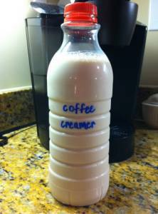
COFFEE DRINKERS....THANK ME LATER....
Homemade Coffee Creamer – Over 2 Dozen Flavor Varieties!
SHARE this to your TIMELINE so you won't lose it.
For whatever flavor of creamer you want, you start off with the same basic ‘base’ recipe.
14oz sweetened condensed milk
1 3/4 cup milk or cream (whole, lowfat, skim, almond, soy, heavy cream, half & half etc – whatever your preference, however the more fat, the more creaminess)
Mix the ingredients together well. Add them to a mason jar and shake it like crazy or you could also opt to use an old (washed) creamer container.
French Vanilla Creamer
2 teaspoons vanilla extract OR vanilla coffee syrup
Vanilla Bean Coffee Creamer
2 teaspoons vanilla bean paste
Chocolate
2-3 tablespoons chocolate syrup
(1 tsp vanilla extract, optional)
Chocolate Almond
1 tablespoon cocoa powder
1 teaspoon almond extract
Strudel
1 tablespoon cinnamon
1 teaspoon vanilla extract
1 teaspoon almond extract
Vanilla Caramel
2 tablespoons caramel ice cream topping
2 teaspoons vanilla extract
Chocolate Raspberry
2 teaspoons cocoa powder
2 tablespoons raspberry syrup
Irish Cream
2 tablespoons chocolate syrup
1 teaspoon instant coffee
1-2 teaspoons vanilla extract
1 teaspoon almond extract
Coconut
2 teaspoons coconut extract
Samoa (like the Girl Scout Cookies)
2 teaspoons coconut extract (or sub coconut milk or cream of coconut, heated & strained, for the milk/cream)
2 tablespoons chocolate syrup
2 tablespoons caramel ice cream topping
Peppermint Patty
2 tablespoons chocolate syrup
1 teaspoon peppermint extract
Cinnamon Vanilla
2 teaspoons cinnamon
2 teaspoons vanilla extract
Pumpkin Spice
3 tablespoons pureed pumpkin
1 teaspoon pumpkin pie spice
4 tablespoons maple syrup
1 teaspoon vanilla extract
Honey Vanilla
1/4 cup honey
2 teaspoons vanilla extract
Almond Joy
1-2 teaspoons coconut extract (or sub coconut milk or cream of coconut if you heat it first, strained, in place of the milk & extract)
1 teaspoon almond extract
2 tablespoons chocolate syrup
Sweet Cream
Use 1 3/4 cups of heavy cream instead of the milk in the base recipe
2 teaspoons vanilla extract OR the inside of a vanilla bean, scraped
1 teaspoon almond extract
Chocolate Orange
2 tablespoons chocolate syrup
1-2 teaspoons orange extract
Hazelnut
2 teaspoons hazelnut extract
Chocolate Hazelnut
2 tablespoons chocolate syrup
2 teaspoons hazelnut extract
Cinnamon Cake
2 teaspoons cinnamon
2 teaspoons vanilla extract
Salted Caramel
2-3 tablespoons caramel ice cream topping
1/2 teaspoon salt
Eggnog
replace milk in base recipe with equal amount of heavy cream
1 teaspoons vanilla extract
2 teaspoons rum extract
1 teaspoon ground nutmeg
Toasted Almond
2 teaspoons almond extract
Directions & Tips:
In all these recipes, anything that has a dry or thick ingredient (like cinnamon, honey, etc..) should be heated up with a small amount of your milk/cream from the base recipe so it can dissolve properly. You don’t want grainy creamer! Then, add the rest of the milk/cream along with the sweetened condensed milk.
If you want really creamy creamer, use heavy cream instead of milk in your base recipe.
You'll want to stick a piece of tape on they mason jar lid with the expiration date from the milk used. Use this as a guideline as to when the creamer should be used by.
Please feel free to play around with amounts of extracts and other ingredients used if you like stronger or less intense flavors!! And, let your imagination turn, and make up your own combinations. Use this as inspiration to create your very own perfect homemade flavored creamer!

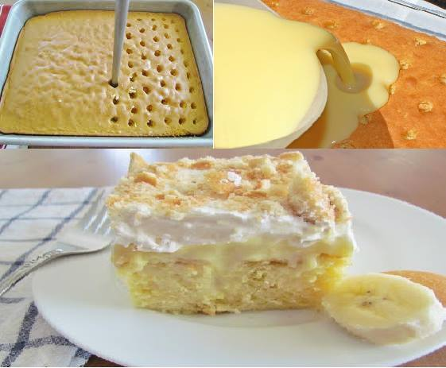
BANANA PUDDING POKE CAKE!!!
Ingredients
1 box yellow cake mix (& ingredients to make cake)
2 box (small) instant banana pudding
4 c milk
8 oz whipped topping
20 vanilla wafers, crushed
sliced bananas - use your own judgment
Directions
1 Follow the direction on the cake mix box to prepare the actual cake. Prepare it in a 9 x 13" pan. When golden, remove from over and let cool for a few minutes.
2 When just slightly cooled, use the end of a wooden spoon (the handle end) to poke holes into the baked cake. Don't be shy; make the holes big enough for the pudding to seep into and go deep enough with the spoon that you hit the bottom of the pan.
3 Next, prepare your pudding mixture. Combine your 4 cups of milk and the instant pudding mix; whisk until fully combined and there are no lumps.
4 Now it's time to fill those holes! Pour the pudding mixture over the entire cake, taking care to get it into all your holes. Use the spoon to help really get it into the cake and spread evenly.
5 Refrigerate for about two hours... or until set. Top with whipped topping, crushed vanilla wafers and sliced banana! Serve and enjoy. (Refrigerate any leftovers.)

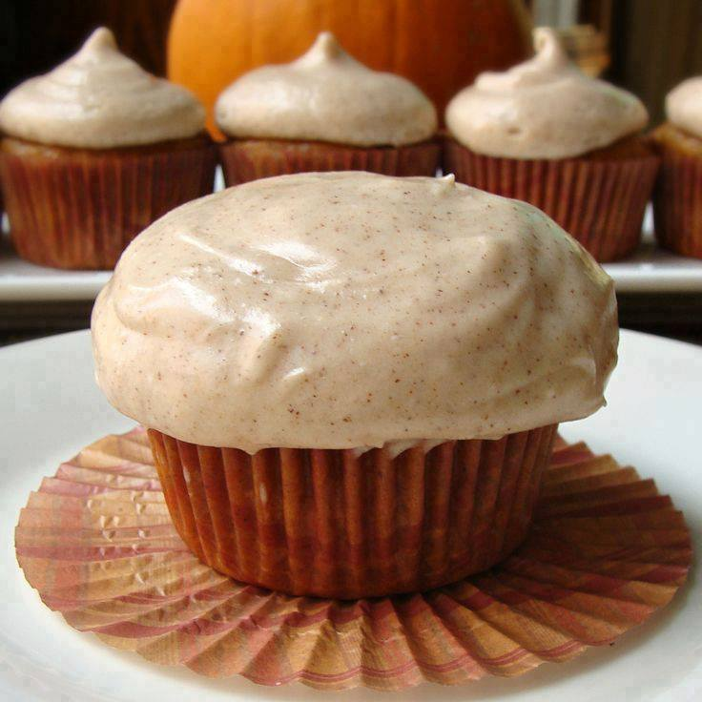
Pumpkin Cupcakes With Cinnamon Cream Cheese Frosting
Yields 24 Cupcakes with Frosting
Ingredients
Cupcakes:
1/4 Cup Butter, Softened
3/4 Cup Unsweetened Applesauce
1 Cup Granulated Sugar
3/4 Cup Brown Sugar, Packed Firmly
2 Large Eggs
3/4 Cup Fat Free Milk
1 Tablespoon Lemon Juice
1 (15 Ounce) Can Pumpkin Puree
2 1/3 Cups All Purpose Flour
1 Tablespoon Pumpkin Pie Spice
1 Teaspoon Ground Cinnamon
1 Teaspoon Baking Powder
3/4 Teaspoon Salt
/2 Teaspoon Baking Soda
1/2 Teaspoon Ground Ginger
Frosting:
1 (8 Ounce) Package Reduced Fat Cream Cheese (Not Fat Free!)
1/4 Cup Butter, Softened
4 Cups Confectioners Sugar
1 Teaspoon Vanilla Extract
2 Teaspoon Ground Cinnamon
Preheat oven to 350 degrees. In a large mixing bowl, add in butter, applesauce, sugars, and eggs and beat over medium speed until combined. Add in pumpkin and continuing beating until thoroughly incorporated. In a liquid measuring cup, combine milk and lemon juice and set aside. In a medium bowl, combine remaining dry ingredients. Slowly, over medium speed, add the dry ingredients to the pumpkin mixture, alternating with the milk mixture, beating well after each addition. Line cupcakes trays with paper liners and then spray lightly with a non-stick cooking spray. Fill cupcake liners 3/4 of the way full and bake for 22 minutes or until a skewer inserted into the middle comes out clean. Remove from oven and allow to cool.
To make frosting, combine all ingredients in a medium mixing bowl and beat over medium speed until ingredients begin to combine, slowly increase speed and continue beating until a frosting is formed. Once cupcakes cool completely, frost as desired and enjoy!

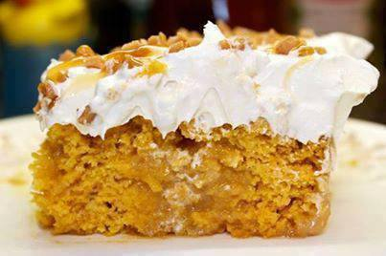
Pumpkin Better Than Sex Cake
•1 box yellow cake mix
•1 – 15 oz. can pumpkin puree (not pumpkin pie mix)
•1 – 14 oz. can sweetened condensed milk (fat free is ok)
•1 – 8 oz. tub cool whip (lite is ok)
•½ bag Heath Bits
•Caramel Sundae Sauce
Instructions
1.In a large bowl, mix together the cake mix and pumpkin puree until a smooth batter forms.
2.Pour batter into a greased 9×13 baking dish, and bake at 350º, according to the directions on the cake mix box (approx 23-28 mins).
3.Remove cake from oven and let cool for about 10 minutes after baking.
4.Using the end of a wooden spoon to poke holes all over the top of the cake.
5.Pour the sweetened condensed milk over the cake. This should fill in the holes and soak into the cake.
6.Refrigerate for 30 minutes.
7.Remove cake from refrigerator and spread cool whip over top of cake. Sprinkle on the heath bits, and drizzle caramel over top. (I didn’t think the cake needed a lot of caramel at this point so I only used about ¼ of the jar. I thinned it out first by heating it in the microwave.)
8.Refrigerate for 3-4 hours, or overnight

Easy Crockpot Chicken Fajitas
INGREDIENTS
1 lb. of Chicken Breasts (or you can use steak strips), 3 Peppers (Green, Red & Yellow) sliced, 1 Onion sliced ,1 Package of Taco Seasoning, Flour or corn tortillas
Toppings - sour cream, cheese, guacamole, etc.
...INSTRUCTIONS
Slice peppers and onions then place them on the bottom of the crock pot
Put Chicken on top of peppers and onions
Sprinkle taco seasoning on the top
Cook on low for 6-8 hrs. (or high for 3-4)
The chicken looks burnt but it's just crispy. Shred everything up and mix in the juice.
Serve with tortillas and all the toppings - sour cream, guacamole, cheese, lettuce, etc.

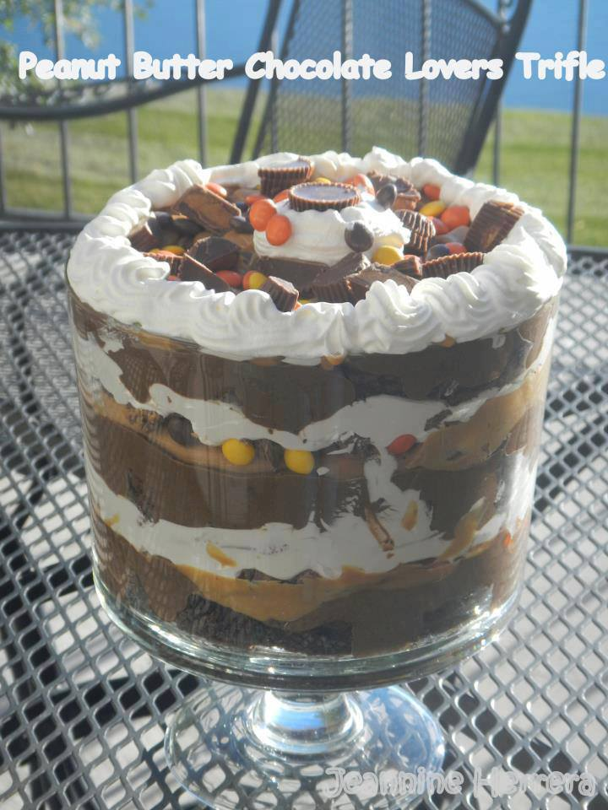
Peanut Butter & Chocolate Lover's Trifle
Ingredients:
• 1 chocolate cake mix
• 2 (4 ounce) packages instant chocolate pudding mix
• 4 cups of milk
• 1/2 cup of heavy cream
• 1 (16 ounce) containers frozen whipped topping, thawed
• 1 (10 ounce) package of peanut butter chips
• 1/4 tsp. of vanilla
• Reese's peanut butter cups (chopped)
• Reese's pieces
Directions:
1. Prepare chocolate cake mix according to package directions and cool completely. Cut into 1 inch squares. (I baked it in my Large Bar Pan- and then I only used about ½ of the cake in the Trifle Bowl- and cut it with my Pizza Cutter)
2. In large bowl combine pudding mix and milk. (Classic Batter Bowl and Stainless Whisk)
3. Melt peanut butter chips, heavy cream and vanilla over low heat until combined. Let cool. (Executive Sauce Pan would be the best for this) (I then put the PB Sauce in a Zip Loc & cut off a corner to drizzle… keep it warm- I had to nuke it for a few seconds a few times to keep it melt-y)
4. In trifle bowl layer the cake, pudding mixture, peanut butter sauce, Reese’s peanut butter cups, Reese’s pieces and whipped topping. Repeat layers until bowl is full. Garnish with Reese’s PB Cups & Reese’s pieces. (Santoku Knife to cut up the PB Cups, Easy Accent Decorator for the Cool Whip)
ENJOY!

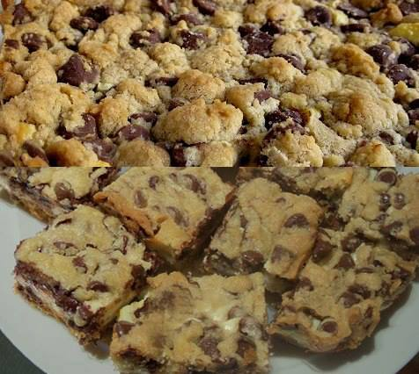
Chocolate Chip Cookie Cheesecake
Ingredients
3 (8-ounce) packages cream cheese, softened
3 eggs
3/4 cup sugar
1 teaspoon vanilla extract
2 (16.5-ounce) rolls refrigerator chocolate chip cookie dough (keep refrigerated until needed)
Instructions
Preheat oven to 350 degrees F.
In a large bowl, beat together cream cheese, eggs, sugar, and vanilla extract until well mixed; set aside.
Slice cookie dough rolls into 1/4-inch slices. Arrange slices from one roll on bottom of a greased 9- x 13-inch glass baking dish; press together so there are no holes in dough. Spoon cream cheese mixture evenly over dough; top with remaining slices of cookie dough.
Bake 45 to 50 minutes, or until golden and center is slightly firm.
Remove from oven, let cool, then refrigerate. Cut into slices when well chilled.
If desired top with ice cream or whipped cream.

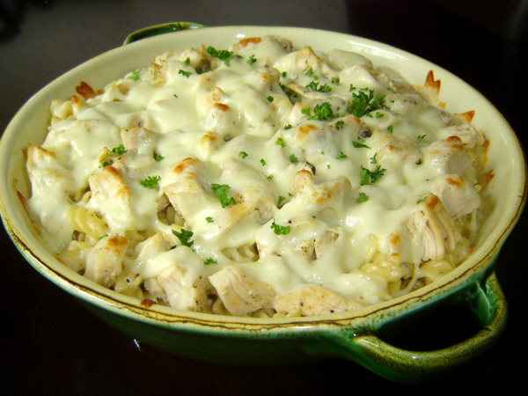
Pizza Hut Tuscani Creamy Chicken Alfredo
Ingredients

1 package rotini pasta[1]
4 chicken breasts
2 cups heavy cream[3]
1 cup mozzarella cheese, shredded
1/2 cup parmesan cheese
1 package cream cheese[4]
3 tablespoons butter
2 cloves minced garlic
1 tablespoon flour
Salt and pepper to taste

Instructions
Cook the rotini pasta according to the instructions on the package.
Heat a grill on high.
Rinse the chicken breasts, pat dry and season with salt and pepper.[5]
Place the chicken on the grill, and let cook for a few minutes. Then flip. Cook until the chicken is no longer pink in the middle, and both sides are browned. Allow the chicken to rest for a few minutes after you remove them from the heat.
Heat the oven to 350 degrees.
Melt the butter in a medium saucepan over medium heat.
Add the garlic, and cook for a minute or two. Be careful not to let the garlic burn.
Stir in the flour, and cook until a thick paste forms.
Add the cream cheese and the heavy cream, a small amount at a time.
Add a cup of water to the mixture and stir well.
Add parmesan cheese, and then salt and pepper to taste.
Slice the chicken breasts into strips.
Add the chicken breasts to the cooked pasta, and mix until evenly distributed.
Pour the chicken and pasta mixture into a lightly greased baking dish.
Pour the sauce over the pasta mixture.
Top with mozzarella cheese, and bake for 20-25 minutes until the pasta is hot and bubbly and the cheese is all melted.
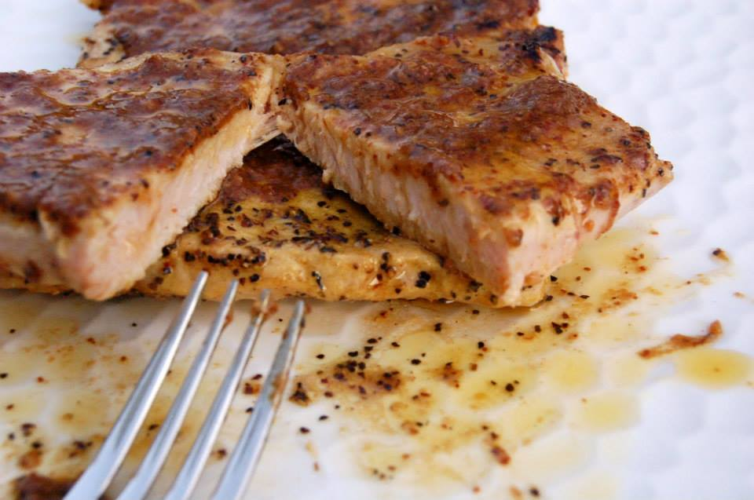
Lemon Pepper Pork Chops
1/2 cup water
1/4 cup light soy sauce
2 Tbsp Worcestershire Sauce
1/4 cup olive oil
3 Tbsp lemon pepper seasoning
2 garlic cloves, minced
6 pork loin chops
In deep bowl mix all marinade ingredients. Pour over pork chops and marinate at least 2 hours.
Remove pork chops from marinade and grill 6 minutes on first side, flip and grill 5 more minutes.

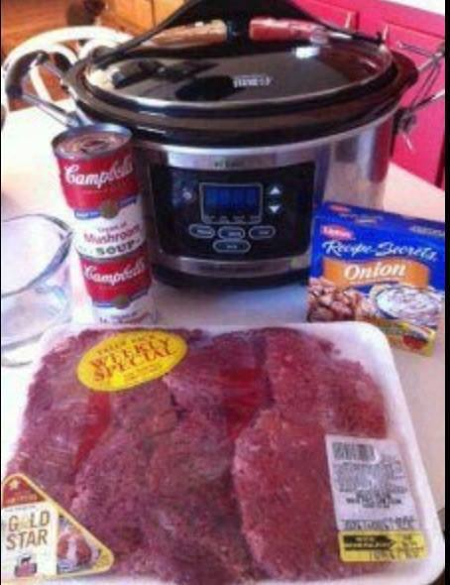
Crockpot Cube Steak and Gravy
Cube steak (I used a family size pack)
2 cans (10.75 ounce size) cream of mushroom soup
1 envelope onion soup mix
3/4 cup water
Salt and Pepper to taste
Directions:
Place all ingredients in a crock pot. Cook on low all day(6-8 hours on low). Serve over rice, noodles, mashed potatoes or with your favorite side dishes.

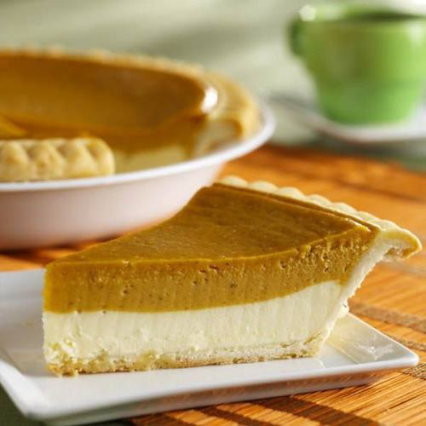
Pumpkin Cheesecake Pie
You Will Need:
2 (8 ounce) packages cream cheese, softened
1/2 cup white sugar
1/2 teaspoon vanilla extract
2 eggs
1 (9 inch) prepared pie crust (or Graham cracker crust, whichever you prefer)
1/2 cup pumpkin puree
1/2 teaspoon ground cinnamon
1 pinch ground cloves
1 pinch ground nutmeg
1/2 cup frozen whipped topping, thawed

Directions:
Preheat oven to 325 degrees F (165 degrees C).
In a large bowl, combine cream cheese, sugar and vanilla. Beat until smooth. Blend in eggs one at a time. Remove 1 cup of batter and spread into bottom of crust; set aside.
Add pumpkin, cinnamon, cloves and nutmeg to the remaining batter and stir gently until well blended. Carefully spread over the batter in the crust.
Bake in preheated oven for 35 to 40 minutes, or until center is almost set. Allow to cool, then refrigerate for 3 hours or overnight. Cover with whipped topping before serving.

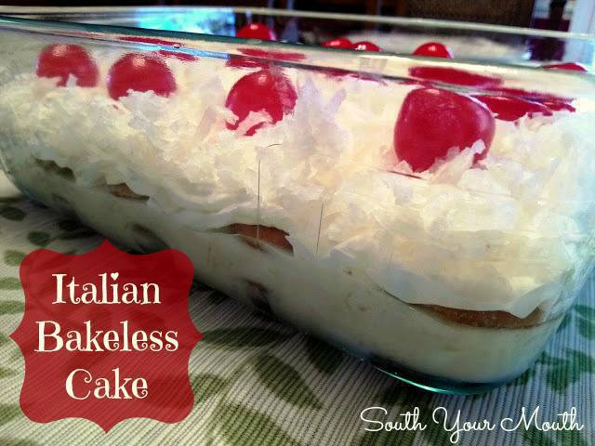
NO BAKE Italian Cake
1 14-oz. can sweetened condensed milk
1/4 cup fresh lemon juice
1 small can crushed pineapple, undrained
40-50 vanilla wafers
1 8-oz. carton cool whip, thawed
2 cups sweetened, flaked coconut
12-16 maraschino cherries, rinsed
Whisk together sweetened condensed milk and lemon juice in a small bowl until thoroughly combined. Mix in pineapple with juice and set aside.
Line the bottom of a small glass baking dish (8x8 or 7x10) with vanilla wafers. Pour all of the pineapple mixture over vanilla wafers then add another layer of vanilla wafers on top of pineapple mixture. Spread cool whip evenly on top of vanilla wafers then sprinkle with coconut. Top with cherries then cover and refrigerate at least 8 hours before serving.

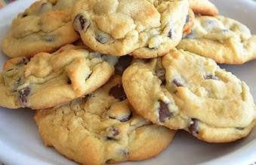
Chocolate Chip Pudding Cookies
Yields 36 cookies
1 cup (2 sticks) Butter, softened
3/4 cup Brown Sugar
1/4 cup White Sugar
1 small pkg Instant Vanilla Pudding mix
2 eggs
1 teaspoon Vanilla Extract
2 1/4 cups All-Purpose Flour
1 teaspoon Baking Soda
1 pkg ( 12 oz) Milk Chocolate Chips
DIRECTIONS: Preheat oven to 375 degrees. Beat the butter, both sugars, pudding mix, eggs and vanilla in a large bowl. Beat until creamy and fluffy. Then slowly mix in flour and baking soda. Stir in chocolate chips.
Drop by tablespoonfuls, onto an ungreased cookie sheet. Bake for ONLY 9-10 minutes. Remove from oven and let cool about 10 minutes before eating.

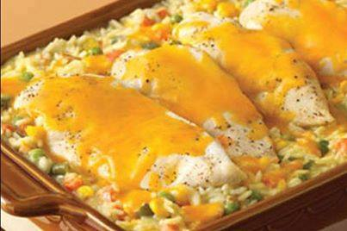
Cheesy Chicken Casserole
Ingredients
10 3/4 ozs cream of chicken soup
1 1/3 cups water
3/4 cup white rice (uncooked long-)
2 cups frozen mixed vegetables
1/2 tsp onion powder
4 boneless, skinless chicken breast halves
1/2 cup shredded cheddar cheese
Directions:
1
Stir the soup, water, rice, vegetables and onion powder in a 12" x 8" shallow baking dish.
2
Top with chicken. Season chicken as desired. Cover.
3
Bake at 375 degrees for 45 minute or until done. Top with cheese.
4
Serve with a green salad and bread of your choice.

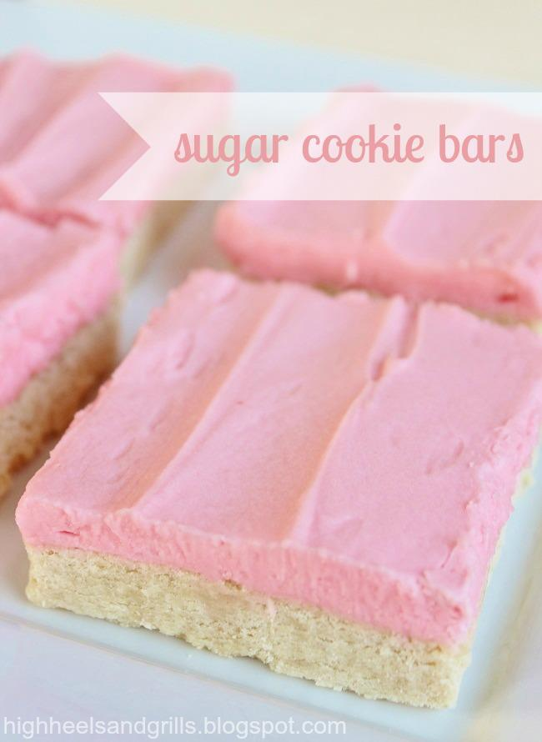
Sugar Cookie Bars
Ingredients:
Cookies:
2-1/2 cups bread flour (or all-purpose flour is fine)
1/2 tsp. baking powder
1/2 tsp. salt
1/2 cup butter, softened
1 cup granulated sugar
1 egg
1-1/2 Tbsp. sour cream
1 tsp. vanilla extract
Frosting:
1/2 cup butter, softened
4 cups powdered sugar
1/4 cup half and half
1 tsp. vanilla
Pinch of salt
Several drops of food coloring (optional)
Directions:
COOKIES: Preheat oven to 375 degrees Fahrenheit and grease a 9x13 inch baking dish.
In a medium bowl, combine flour, baking powder, and salt. Set aside.
In a large bowl, cream together butter and sugar until light and fluffy, about 3 minutes. (The longer you beat it, the fluffier your cookies will be.)
Add egg and combine well.
Add sour cream and vanilla and mix until completely blended.
Slowly add the flour mixture and stir until well combined.
Gently press the batter into the greased baking dish and spread out with hands. (If you butter your hands, this will help with the stickiness.)
Bake 17-20 minutes, or until edges become lightly golden.
Set aside to cool completely.
FROSTING: In a medium bowl, cream together butter, powdered sugar, and half and half until light and fluffy.
Stir in vanilla and salt, combine well.
Add food coloring until desired color.
Frost your cooled cookie bars evenly.
Cut into squares and serve.
I have to warn you - these are kind of addicting. Like, scary addicting. But, they honestly might just be worth the few extra pounds. Enjoy
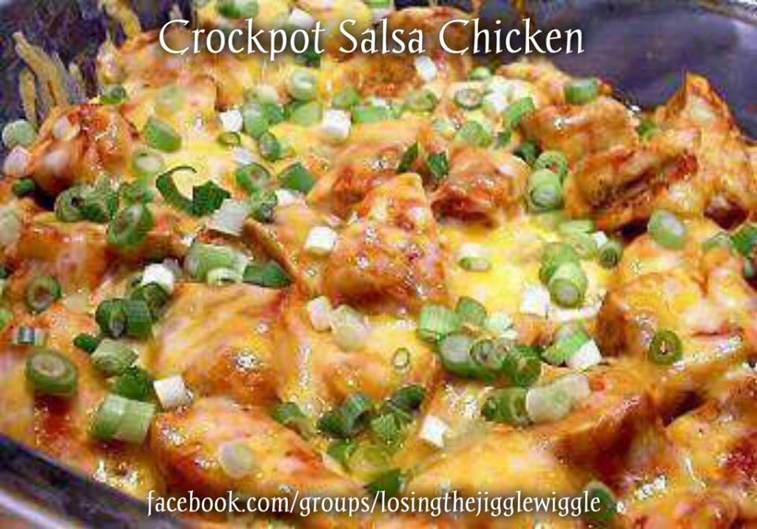
SLOW-COOKER SALSA CHICKEN!
Ingredients
2 lbs. (32 oz.) chicken breasts, boneless and skinless
1 cup salsa, homemade or purchased
1 cup petite diced canned tomatoes (choose low-sodium)
2 tbsp. taco seasoning
1 cup onions, diced fine
1/2 cup celery diced fine
1/2 cup carrots, shredded
3 tbsp. sour cream, reduced fat
Directions
Place the chicken in a slow cooker. Sprinkle the taco seasoning over the meat then layer the vegetables and salsa on top. Pour a half cup water over the mixture, set on low and cook for 6-8 hours. The meat is cooked when it shreds or reaches an internal temperature of 165°F. When ready to serve, break up the chicken with two forks then stir in the sour cream.
Makes eight 1 cup servings.

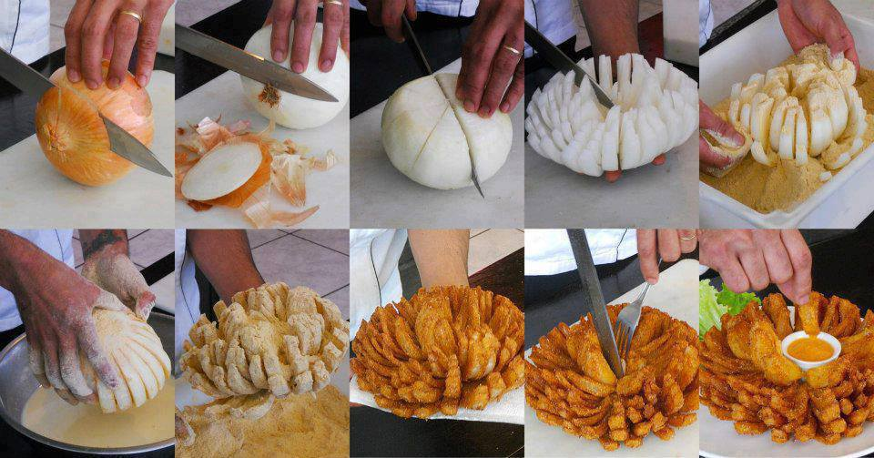
Outback Steakhouse Bloomin Onion!
Batter
1/3 cup cornstarch
1 1/2 cups flour
2 teaspoons garlic, minced
2 teaspoons paprika
1 teaspoon salt
1 teaspoon pepper
24 ounces beer
4 vidalia onions
Seasoned flour
2 cups flour
4 teaspoons paprika
2 teaspoons garlic powder
1/2 teaspoon pepper
1/4 teaspoon cayenne
Outback Dipping Sauce
1/2 cup mayonnaise
2 teaspoons ketchup
2 teaspoons creamed horseradish
1/4 teaspoon paprika
1/4 teaspoon salt
1/8 teaspoon dried oregano
1 dash black pepper
1 dash cayenne
Directions:
1. for the seasoned flour-combine flour, paprika, garlic powder, pepper and cayenne-mix well.
2. For the Dipping sauce - Blend everything together well and refrigerate for 2 hours or overnight.
3. For the batter -Mix cornstarch, flour and seasonings until well blended.
4. Add beer and mix well.
5. Cut about 3/4 inch off top of onion and peel.
6. Cut into onion 12-16 vertical wedges but do not cut through bottom root end.
7. Remove about 1 inch of petals from center of onion (You can place the cut onions in cold water for a few hours to help "open" them up -- just make sure that you drain them well).
8. Dip in seasoned flour and gently shake to remove excess.
9. Separate petals to coat thoroughly with batter.
10. Gently place in a fryer basket and deep fry at 375-400 for 1 1/2 minutes.
11. Turn over and fry 1 1/2 minutes more or until golden brown.
12. Drain on paper towels.
13. Place onion upright in a shallow bowl and remove center core with a circular cutter or apple corer.
14. Serve hot with dipping sauce.

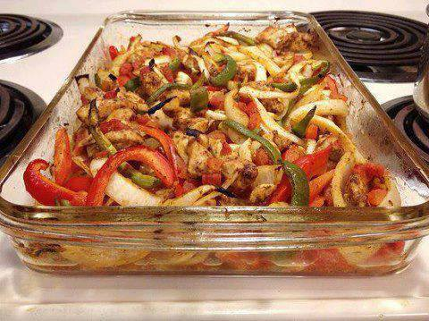
Oven Baked Fajita
Ingredients:
1 pound boneless, skinless chicken breasts, cut into strips
2 Tbsp vegetable oil
2 tsp chili powder
1 1/2 tsp cumin
1/2 tsp garlic powder
1/2 tsp dried oregano
1/4 tsp seasoned salt
1 (15 oz) can diced tomatoes with green chilies (Rotel)
1 medium onion, sliced
1/2 red bell pepper, cut into strips
1/2 green bell pepper, cut into strips
Directions:
Preheat the oven to 400 degrees. Place chicken strips in a greased 13×9 baking dish.
In a small bowl combine the oil, chili powder, cumin, garlic powder, dried oregano, and salt.
Drizzle the spice mixture over the chicken and stir to coat.
Next add the tomatoes, peppers, and onions to the dish and stir to combine.
Bake uncovered for 20-25 minutes or until chicken is cooked through and the vegetables are tender.

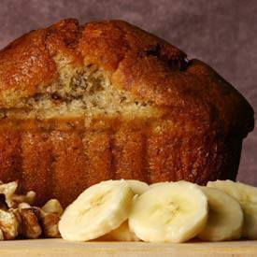
Banana Bread with Honey and Applesauce

Ingredients
2 cups whole wheat flour
1 teaspoon baking soda
1/4 teaspoon salt
1/2 cup unsweetened applesauce
3/4 cup honey
2 eggs, beaten
3 mashed overripe bananas
Directions
Preheat oven to 350 degrees F (175 degrees C). Lightly grease a 9x5 inch loaf pan. In a large bowl, combine flour, baking soda and salt. In a separate bowl, mix together applesauce and honey. Stir in eggs and mashed bananas until well blended. Stir banana mixture into flour mixture; stir just to moisten. Pour batter into prepared loaf pan.
Bake in preheated oven for 60 to 65 minutes, until a toothpick inserted into center of the loaf comes out clean. Let bread cool in pan for 10 minutes, then turn out onto a wire rack.

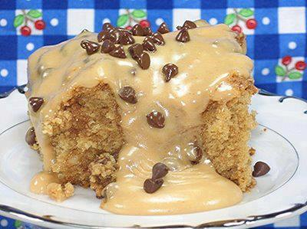
PEANUT BUTTER CAKE - PEANUT BUTTER FROSTING
2 & 1/4 CUPS ALL PURPOSE FLOUR
2 CUPS LIGHT BROWN SUGAR (packed)
1 CUP PEANUT BUTTER
1/2 CUP BUTTER (room temperature)
1 TEASPOON BAKING POWDER
1/2 TEASPOON BAKING SODA
1 & 1/4 CUPS MILK
2 TEASPOONS VANILLA EXTRACT
3 EGGS
Preheat your oven to 350 and grease and flour a 10 x 15 cake pan. In a large bowl, mix the first 4 ingredients with an electric mixer; blend at low speed until crumbly. Add the next 5 ingredients and blend at low speed until everything is wet, then beat at medium speed for 3 minutes.
Pour into prepared pan and bake, in the middle of your oven, for 35-40 minutes or until the toothpick test comes out clean.
Let the cake cool (in the pan) for 10 minutes, then spread the frosting on the hot cake (recipe follows) and sprinkle one cup of mini-chocolate chips over the frosting.
PEANUT BUTTER-HONEY FROSTING
1/2 CUP PEANUT BUTTER + 2 TABLESPOONS HONEY + 1 TEASPOON VANILLA EXTRACT + 2 CUPS POWDERED SUGAR + 4 to 5 TABLESPOONS MILK
Warm the peanut butter and honey in the microwave just until it gets soft and easy to stir, then add everything else and beat until smooth. Spread over hot cake and sprinkle with one cup of mini-chocolate chips.
NOTE: You might like to double the frosting -- but still only use one cup of mini-chocolate chips.

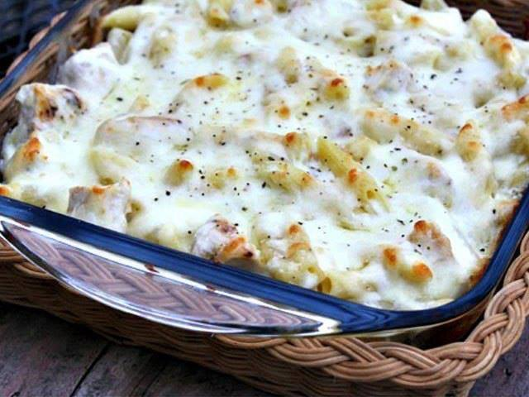
Chicken Alfredo Casserole
This is quick, easy and tasty!! Made it for our dinner last nite with some steamed broccoli and carrots and garlic toast
2 dry cups pasta (shells or elbow macaroni are really good for this recipe)
1 15-16 oz jar of a GOOD Alfredo sauce
1-2 cups cooked chicken, shredded or chunked
1/2 cup chicken broth
5 oz shredded Parmesan cheese
2 cups shredded mozzarella cheese (one 8 oz bag)
1-1/2 tsp minced garlic
salt and pepper to taste
Preheat oven to 350*.
Prepare pasta according to package directions.
In medium bowl, combine pasta, Alfredo sauce, cooked chicken, chicken broth, garlic, salt and pepper, shredded Parmesan cheese and mix well.
Grease 9x13 baking dish.
Pour chicken mixture into baking dish.
Sprinkle mozzarella cheese on top.
Bake uncovered for 30-35 minutes.

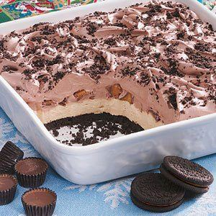
Oreo/Peanut Butter Cup no-bake Dessert
Ingredients
20 chocolate cream-filled chocolate sandwich cookies, divided
2 tablespoons butter, softened
1 package (8 ounces) cream cheese, softened
1/2 cup peanut butter
1-1/2 cups confectioners' sugar, divided
1 carton (16 ounces) frozen whipped topping, thawed, divided
15 miniature peanut butter cups, chopped
1 cup cold milk
1 package (3.9 ounces) instant chocolate fudge pudding mix

Directions
Crush 16 cookies; toss with the butter. Press into an ungreased 9-in. square dish; set aside.
In a large bowl, beat the cream cheese, peanut butter and 1 cup confectioners' sugar until smooth. Fold in half of the whipped topping. Spread over crust. Sprinkle with peanut butter cups.
In another large bowl, beat the milk, pudding mix and remaining confectioners' sugar on low speed for 2 minutes Let stand for 2 minutes or until soft-set. Fold in remaining whipped topping.
Spread over peanut butter cups. Crush remaining cookies; sprinkle over the top. Cover and chill for at least 3 hours. Yield: 12-16 servings

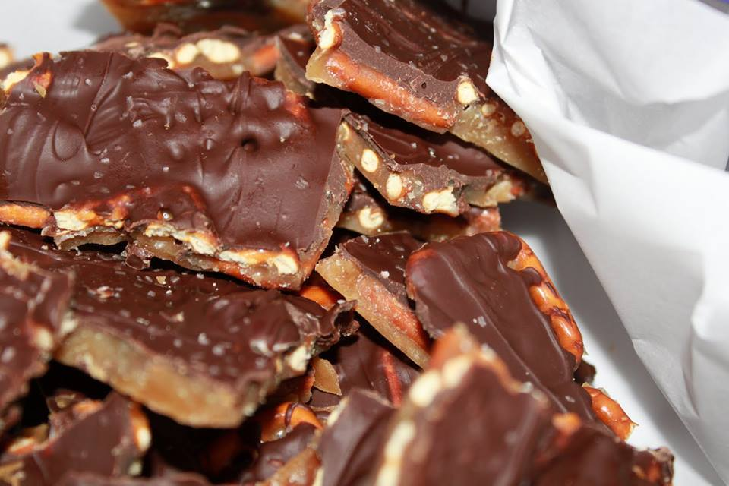
Salted Caramel Pretzel Bark
this is sooo easy to make!
2 sticks of butter
1 cup of light brown sugar
1 reg. bag of pretzels (you'll use about 3/4 of the bag)
12 ounce bag of chocolate chips
Sea salt - ( I use our coarse sea salt with our grinder)
Preheat the oven to 400.
Line a large bar pan with parchment paper, cover with pretzels
In a medium saucepan melt the butter over medium-low heat. When it begins to bubble add the brown sugar. Stirring occasionally let the butter/sugar mixture meld together and brown. This should take about 3 minutes. Do NOT let it boil, you will have sticky goo that is no good. When you have a nice, brown caramel pour it over the pretzels, slowly and evenly. You can then use a spatula to spread it out, you have to work quickly and gently. It hardens fast so even pouring is the best method.
Bake the sheet for 5 minutes.
Remove the sheet from the oven and sprinkle the whole bag of chocolate chips evenly over the mixture.
Place back in the oven for about 45 seconds. If you let it sit there too long the chocolate will burn.
Remove from the oven and use a silicone spatula to evenly spread the chocolate over the top.
Sprinkle with sea salt and refrigerate for a minimum of 1 hour.

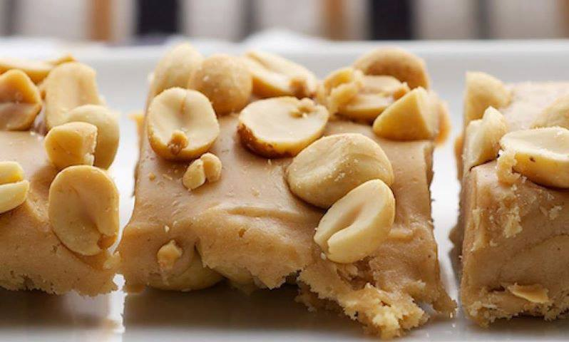
Salted Nut Squares
Tastes just like payday candy bar
And NO BAKE!!!
: about 30 bars
Ingredients
3 cups salted peanuts (no skins), divided
2 & 1/2 tablespoons butter
2 cups peanut butter chips
14 ounces sweetened condensed milk
2 cups miniature marshmallows
kosher salt or sea salt, optional
Instructions
Place 1 & 1/2 cups peanuts in the bottom of an ungreased 11″x 7″ pan.
Melt butter and peanut butter chips in a large saucepan over low heat. Stir until smooth.
Remove from heat. Stir in condensed milk and marshmallows. Continue stirring until smooth and well-blended.
Pour peanut butter mixture over peanuts in pan. Sprinkle remaining 1 & 1/2 cups peanuts over top of peanut butter mixture. If saltier bars are desired, sprinkle lightly with salt.
Cover and refrigerate until chilled. Then, cut into bars. Bars can be served chilled or at room temperature.
Notes
These can be made in a 9″x 13″ pan. Use another cup of peanuts, divided between the bottom of the pan and the top of the bars. The same amount of filling will work and give you slightly thinner bars.

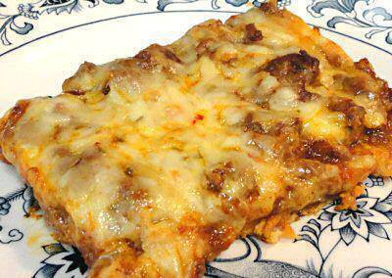
ENCHILADA BAKE
Crust:
4 ounces cream cheese, softened
2 eggs
1/2 teaspoon Taco Seasoning
8 ounces cheddar cheese, shredded
1/4 ounce tortilla chips, finely crushed *
Beat or whisk the cream cheese and eggs until smooth. Add the seasoning; mix well. Stir in the cheese and crushed chips; mix well. Grease a 9x13" baking dish or line with parchment paper; spread the cheese mixture evenly over the bottom. Bake at 350º, 35 minutes or until browned, but not too dark. Let stand 5-10 minutes before adding the topping.
* 1/4 ounce is about 4-5 small round tortilla chips. I used the unflavored white corn kind. They only add about 4 carbs to the whole recipe.
Topping:
1 pound ground beef
1 tablespoon Taco Seasoning
1/2 batch Red Enchilada Sauce (about 1 cup)
8 ounces pepper-jack cheese, shredded
Brown the hamburger; drain fat. Stir in the seasoning and enchilada sauce. Spread over the crust. Top with the cheese. Bake another 20 minutes or so until hot and bubbly.
Makes 8 servings

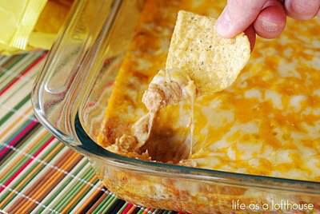
Texas Trash Warm Bean Dip
1 (8 ounce) package cream cheese, softened
1 cup sour cream
2 cans (16 ounces, each) refried beans
1 packet taco seasoning
2 cups cheddar cheese, shredded
2 cups monterey jack cheese, shredded
DIRECTIONS: Preheat oven to 350 degrees. Mix together cream cheese and sour cream in a large bowl. Mix in refried beans until combined. Stir in taco seasoning.
Spray a 9x13 baking pan with cooking spray. Spread mixture evenly into the bottom of the baking dish. Sprinkle the top with both cheeses.
Bake for 25-30 minutes, or until cheese in melted and slightly browned. Serve with tortilla chips.

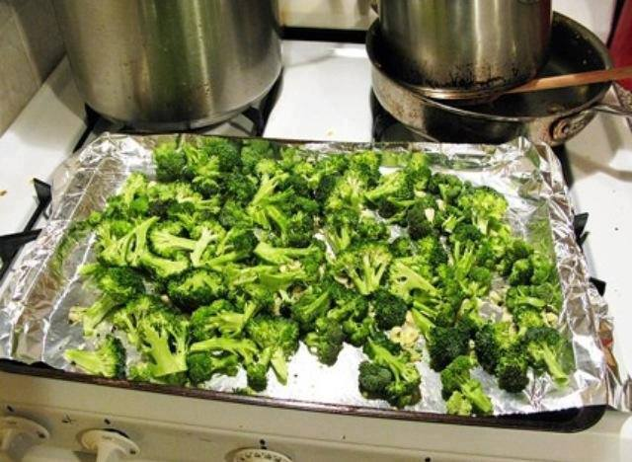
Baked Broccoli
Preheat oven to 375°
Chop a head of broccoli (do not rinse, immediately prior to preparing!)
Mince 2-3 cloves of garlic
Put broccoli, garlic, 2 tbsp. olive oil, and a few shakes of salt and pepper in a ziploc bag.
Shake it up!!
Spread out on baking sheet, place on top rack, and bake for about 30 minutes.
Broccoli will be crunchy and delicious! I make this at least 3 times a week and have to control myself once I take it out of the oven, I could eat this alone for dinner!

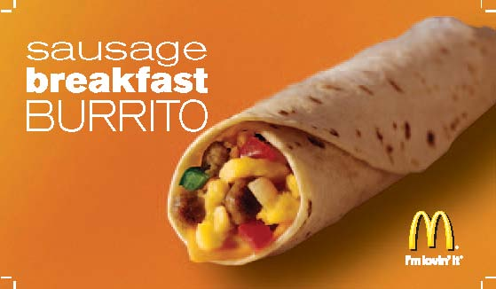
McDonald’s Breakfast Burrito

1 pound Rolled Pork Sausage (mild)
1/2 cup Yellow Onion (diced)
1/4 cup Fresh Tomatoes (diced)
1 tablespoon Green Chili's (diced those in a can)
10 - 12 count package Flour Tortillas Shells (8"-9" diameter)
9 Eggs ( 2 cups)
10 - 12 Slices American Cheese
Favorite Taco Sauce or Picante Sauce
Crumble and fry pork sausage, stir and separate meat so it will fry in small little pieces. Remove from heat drain and rinse with hot water, drain water from sausage. Place drained sausage in fry pan add onion, green chili's and tomatoes, heat on medium temperature just until sausage and vegetables are heated through, stir frequently.
Measure 2 cups of eggs and beat. Add the eggs to the pan with the sausage mixture. When cooked remove from heat. Cover and store the sausage mixture that is not used and refrigerate. It will keep for several days for your next breakfast. In the middle of one flour tortilla shell place one slice of cheese in the middle. Spoon one - two tablespoons of the egg mixture and roll up the shell. Place on platter and cover with plastic and pop in microwave just long enough to heat and melt cheese. Serve with your favorite taco or Picante sauce. You will find these are milder and relay great for breakfast. I like to place sour cream and little avocado in mine.

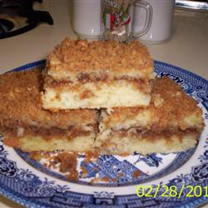
Sour Cream Graham Streusel Cake
8 squares Graham Crackers
1/4 cup chopped Pecans
2 tablespoons Packed Brown Sugar
1/2 teaspoon Ground Cinnamon
3 tablespoons Butter
1 cup Flour
1/2 teaspoon Baking Powder
1/2 cup Butter, softened
1/4 cup Sugar
1/2 teaspoon Vanilla
1/2 teaspoon Grated Lemon Peel
1/2 cup Sour Cream
Preheat oven to 350 degrees. Grease 8 inch round cake pan, and set aside. Crush graham crackers until they are fine crumbs. Crush enough crackers to make 3/4 cup. Combine graham cracker crumbs, pecans, brown sugar, and cinnamon in a small bowl. Add melted butter, stir until well blended. Sift together flour, baking powder and baking soda into medium bowl. Beat softened butter and granulated sugar in large bowl with electric mixer at medium speed until light and fluffy. Beat in vanilla and lemon peel. Reduce speed to low. Add flour mixture alternately with sour cream, beating well after each addition.
Spoon half of batter into prepared pan, spreading evenly. Sprinkle 2/3 crumb mixture evenly over batter. Spoon remaining batter over crumbs lightly into batter. Bake at 30 to 35 minutes or until toothpick inserted into center comes out clean. Let cool ten minutes before removing from pan.

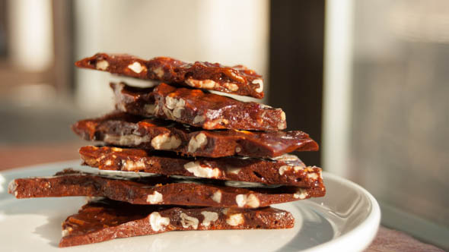
Beer Bacon Brittle
1/2 cup (1 stick) butter
2 cups sugar
1/2 cup nut brown ale, preferably oak barrel aged
1 teaspoon sea salt
1/2 cup bacon, cooked and crumbled
Rounded 1/2 cup crisped rice cereal
Rounded 1/2 cup spiced pecans
Lightly butter a baking sheet and set aside.
In a large saucepan, melt butter over medium heat. Add sugar, beer and salt and continue to stir over low heat until sugar is dissolved. Bring sugar mixture to a boil and cook to hard crack stage, 300°F.
Remove from heat and stir in bacon, rice cereal and pecans before quickly pouring onto prepared cookie sheet.
Let brittle cool to room temperature, then crack into bite size pieces. Store in an airtight container for up to 1 week.

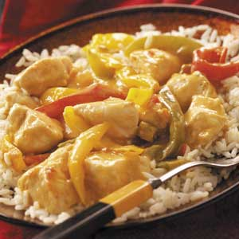
Nacho Chicken & Rice

Ingredients
2-1/2 pounds boneless skinless chicken breast halves, cubed
1 each small green, sweet red and orange peppers, cut into thin strips
1 can (10-3/4 ounces) condensed nacho cheese soup, undiluted
1/2 cup chunky salsa
1/8 teaspoon chili powder
4-1/2 cups hot cooked rice

Directions
In a 3-qt. slow cooker, combine the chicken, peppers, soup, salsa and chili powder. Cover and cook on low for 5-6 hours or until chicken is tender. Serve with rice. Yield: 6 servings.

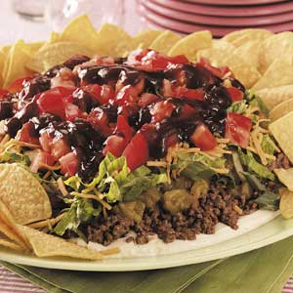
Barbecue Beef Taco Plate

Ingredients

4 pounds ground beef
2 envelopes taco seasoning
1 cup water
4 packages (8 ounces each) cream cheese, softened
1 cup 2% milk
2 envelopes ranch salad dressing mix
4 cans (4 ounces each) chopped green chilies, drained
1 cup chopped green onions
3 to 4 cups shredded romaine
2 cups (8 ounces) shredded cheddar cheese
4 medium tomatoes, seeded and chopped
2 to 3 cups honey barbecue sauce
2 to 3 packages (13-1/2 ounces each) tortilla chips

Directions
In a Dutch oven, cook beef over medium heat until no longer pink; drain. Stir in taco seasoning and water. Bring to a boil. Reduce heat; simmer, uncovered, for 15 minutes.
In a large bowl, beat the cream cheese, milk and dressing mixes until blended. Spread over two 14-in. plates. Layer with the beef mixture, chilies, onions, romaine, cheese and tomatoes. Drizzle with barbecue sauce.
Arrange some tortilla chips around the edge; serve with remaining chips. Yield: 2 plates (20 servings each).

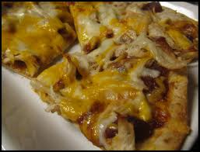
BBQ Ranch Chicken Pizza

1 pizza dough
2 chicken breast
2 garlic clove
6 slices bacon, cooked and crumbled
3/4 cup ranch dressing
3/4 cup barbecue sauce
2 chopped shallot
1/2 cup chopped black olives
2 cup shredded mozzarella cheddar blend cheese
4 tablespoons parmesan cheese, for dough

Directions:

- Prepare Pizza dough and spread in pizza pan. Sprinkle with parmesan cheese. Place in a 375 degree oven for 5 minutes to precook the dough. While the dough is precooking chop the chicken into bite sized bits and stir fry with garlic until cooked through. Chop the bacon into bits, chop the scallions into bits, chop the olives into bits.

- mix the Ranch dressing with the BBQ sauce until combined.

- After 5 minutes take the dough out of the oven. Spoon the Ranch/BBQ sauce over the dough. Top with the chicken, bacon, scallions and black olives. Top with cheese mixture. Sprinkle a little more Parmesan cheese.

- Put back into the oven for 10 additional minutes. When the cheese is melted and bubbly take it out. Let the pizza sit for a minute or two on the counter then slice and enjoy.

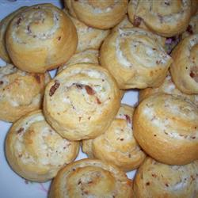
Bacon Cheese Treats

1 (8 ounce) package cream cheese, softened
1 (12 ounce) jar bacon bits
1 pinch ground black pepper, or to taste
1/4 cup diced onion
2 (8 ounce) packages refrigerated crescent roll dough

Directions
Preheat oven to 350 degrees F (175 degrees C).
In a mixing bowl, combine the cream cheese, bacon bits, pepper and onion.
On a lightly floured surface, unroll the crescent rolls lengthwise and form into a long rectangle. Thinly spread the cream cheese mixture on the dough. Starting with the long edge of the rectangle, roll the dough into a long, thin roll. Slice the roll into 1/4 inch thick pieces. Place rolls on a lightly greased baking sheet.
Bake in preheated oven for 15 minutes, or until brown.

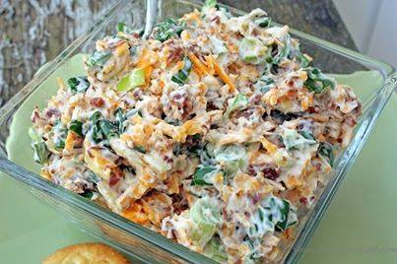
Million Dollar Dip
5 green onions, chopped
8 oz. cheddar cheese, shredded
1- 1/2 cups mayonnaise
1 jar Hormel Real Bacon Bits
1 pkg. slivered almonds
Mix the onions, cheese, mayo, bacon bits, and slivered almonds together. Chill for 2 hours.
Serve with favorite cracker. (Tastes best with butter flavored crackers such as Ritz or Club).

Variations: Add Crab Meat

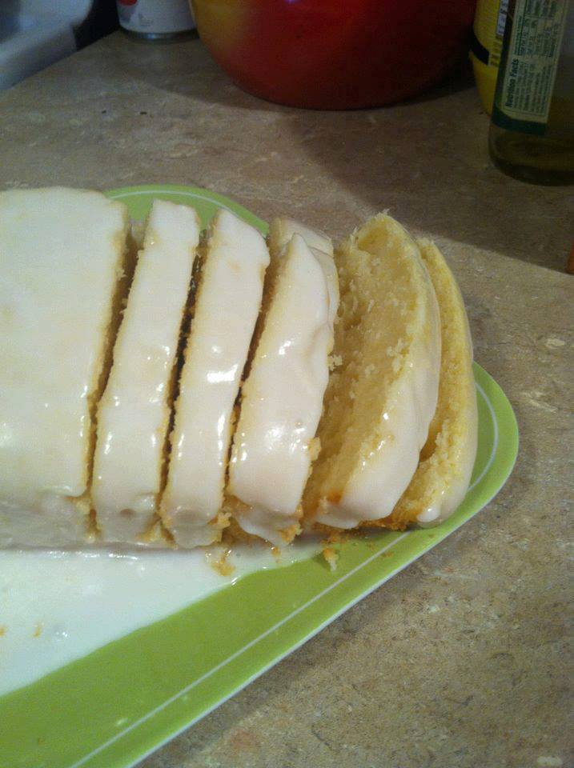
STARBUCKS LEMON LOAF
This is a Top Secret recipe version of Starbucks Lemon loaf.
Ingredients:
1 1/2 cup(s) FLOUR
1/2 tsp BAKING SODA
1/2 tsp BAKING POWDER
1/2 tsp SALT
3 EGGS
1 cup(s) SUGAR
2 TBS BUTTER; Softened.
1 tsp VANILLA
1 tsp LEMON EXTRACT
1/3 cup(s) LEMON JUICE
1/2 cup(s) OIL
Lemon Icing Ingredients:
1 cup POWDERED SUGAR; Plus 1 Tablespoon.
2 TBS WHOLE MILK; I Used 2%.
1/2 tsp LEMON EXTRACT
Instructions:
Combine flour, baking soda, baking powder and salt in a bowl.
Use a mixer to blend together the eggs, sugar, butter, vanilla, lemon extract and lemon juice in a medium bowl.
Pour wet ingredient into the dry ingredients and blend until smooth.
Add oil and mix well.
Pour batter into a well greased 9x5-inch loaf pan.
Bake at 350 degrees for 45 minutes or until a toothpick stuck into center of the cake comes out clean.
Make the lemon icing by combining all the icing ingredients in a small bowl with an electric mixer on low speed.
When the loaf is cool, remove it from pan and frost the top with the icing.
Let the icing set up before slicing.
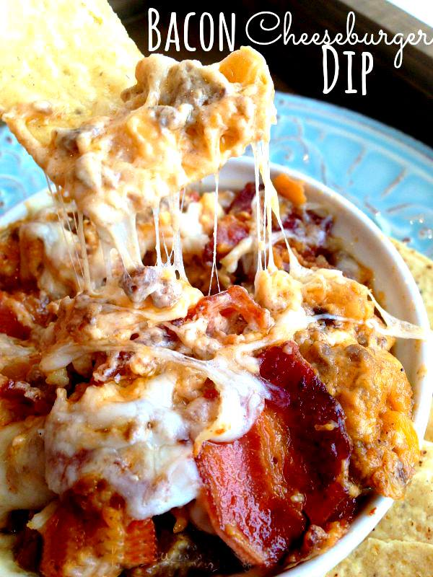
Bacon Cheeseburger Dip
(careful~ this is addicting!)
1/2 pound ground beef
8 bacon strips (cut into chunks)
1/2 diced onion
1 clove garlic - chopped
4 oz cream cheese (softened)
1 tablespoon worcestershire sauce
2 tablespoons ketchup
1/2 cup sour cream
1/4 cup mayonnaise
1/2 cup mozzarella, shredded
1/2 cup cheddar cheese, shredded
Pre-heat oven to 350º. Cook ground beef; drain.
Cook bacon until crispy (drain; keep 1-1/2 T grease in pan).
Saute onion and garlic in grease. In a large bowl mix cream cheese, sour cream, mayonnaise, cheese, worcestershire and ketchup. Add beef, bacon, onions and garlic to mixture above and stir until combined.

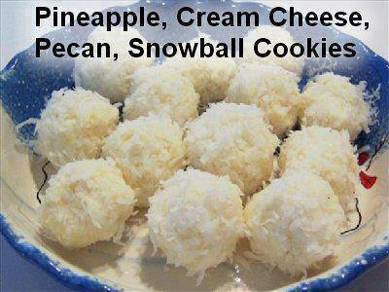
NO BAKE - Cream Cheese, Coconut, Snowball's
1 package (8 ounces) cream cheese, softened.
1 can (8 ounces) crushed pineapple, well drained.
1 cup chopped pecans
3 cups flaked coconut.
In a small bowl, beat cream cheese and pineapple until combined then fold in the pecans. Cover and refrigerate for 1 hour.
Take out of refrigerator and roll into 1-inch balls; then roll the balls in the coconut. Refrigerate for 4 hours or overnight.
Yield: about 2 dozen.

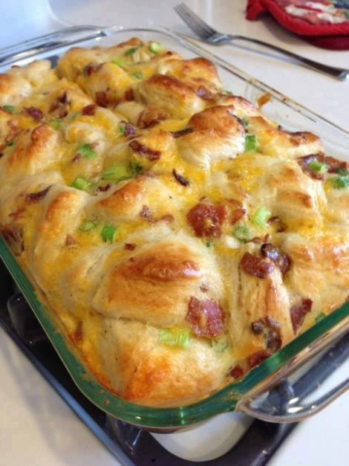
Comfort Breakfast Bake
5 eggs
1/4 cup milk
16 oz refrigerated breakfast biscuits (I used the Pillsbury flakey kind)
4 scallions (green onions, spring onions, whatever you prefer to call them)
1 cup shredded extra sharp cheddar cheese
If you’re into the meats – cooked center cut bacon or cooked sausage
11×17 pan, sprayed with cooking spray (Note: I think a 9×13 works better, but it might need to bake a little longer)
1. Mix your eggs and milk in a large bowl. Cut each biscuit (I’m all about scissors in the kitchen) into fours and add it to the bowl. I like to do this before I cook the bacon or cut up the scallions – give the biscuits some time to really soak in the eggs.
2. Cut up your scallions, shred your cheese, cook and break up your bacon (or sausage). Add everything to the bowl.
3. Mix it all up and pour into your pan. Bake at 350 for 25 minutes (make sure it isn't runny – mine this morning took 28 mins).
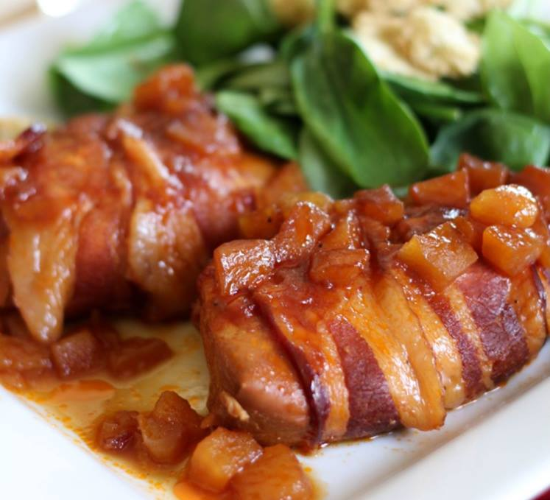
Slow Cooker Bacon-Wrapped Apple Chicken
INGREDIENTS
4 boneless skinless chicken breasts
1 cup BBQ sauce I LOVE Sweet Baby Rays
1/4 cup brown sugar
1/8 cup lemon juice fresh or from a bottle
5 small apples peeled and chopped, I used gala
8 slices bacon
INSTRUCTIONS
In a small bowl, combine BBQ sauce, brown sugar, lemon juice and peeled/chopped apples.
Wrap each chicken breast with two slices of bacon and place in a greased slow cooker.
Pour BBQ-apple mixture over chicken and cook on low for 6-8 hours or until chicken is done.

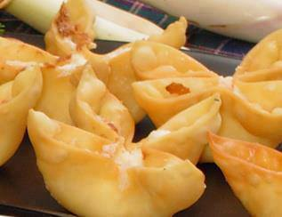
Baked Crab Rangoon
1/8 tsp garlic salt
1/8 tsp Worcestershire sauce
1 small green onion
4 oz imitation crab
3 oz cream cheese
14 wonton wrappers
Cut up the crab and mix it in with garlic salt, worcestershire sauce, green onion and cream cheese (i would microwave the cream cheese for about 40 seconds to soften)
Spoon into wontons.
Bake at 425 F for 8-10 minutes or until golden brown

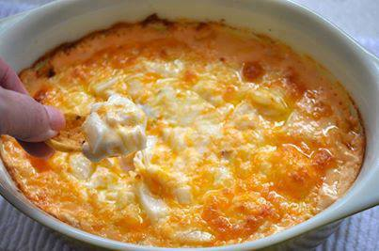
The Cheese Dip That Will Make You Famous!
I call this The Cheese Dip that will make you famous because it’s guaranteed to be the hit of the party! Serve it at your Super Bowl Party, serve it at a cocktail party, serve it anywhere and you’ll get rave reviews! It’s super easy, and you’ll have everyone asking for the recipe. Try it with jalapeño jack or chipotle seasonings if you like a kick…otherwise, stick to the cheddar.
Ingredients
1 8 oz. package cream cheese
2 cups grated cheddar cheese OR grated jalapeño jack
1 cup mayonnaise
1 small purple onion, diced (you can use chopped green onions as well or omit onions if you don’t like them)
◦Serve with Wheat Thins or Frito’s Scoops for dipping or evenVeggies
Instructions
1. Place all ingredients in a shallow baking dish (a 9″ square pan or round quiche pan will be perfect!)
2. Microwave on high for about 2 minutes or until the ingredients are melted enough to stir together.
3. Stir until combined.
4. Bake at 350 for 20 minutes or until lightly browned.
5. Serve with Wheat Thins or Frito’s Scoops for dipping

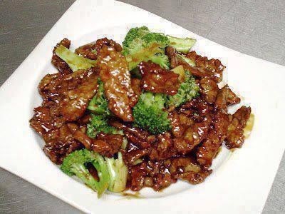
CROCKPOT BEEF AND BROCCOLI
Ingredients
1 pound boneless beef chuck roast, sliced into thin strips
1 cup beef consumme
½ cup soy sauce
⅓ cup brown sugar or honey
1 tablespoon sesame oil
3 garlic cloves, minced
2 tablespoons cornstarch
2 tablespoons cooled sauce from the crock pot after being cooked
Fresh broccoli florets (as many as desired)
Hot cooked rice (brown rice, or riced cauliflower)
Directions
1. Place beef in a crock pot.
2. In a small bowl, combine consomme, soy sauce, brown sugar/honey, oil, and garlic. Pour over beef. Cook on low for 6-8 hours.
3. In a cup, stir cornstarch and sauce form the crock pot until smooth. Add to crock pot. Stir well to combine. (If your sauce is not thickening, try bringing your sauce to a boil on the stovetop with the corn starch mixture. Boil until your desired consistency is reached).
4. Add broccoli to the crock pot. Stir to combine.
5. Cover and cook an additional 30 minutes on high (the sauce has to boil for it to thicken).
6. Serve over hot cooked rice.

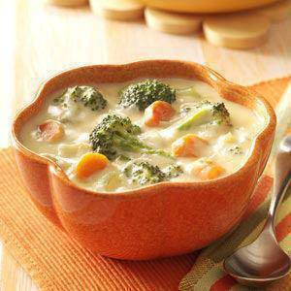
Broccoli Cheese Soup Recipe
Ingredients
•2 cups sliced fresh carrots
•2 cups broccoli florets
•1 cup sliced celery
•1-1/2 cups chopped onion
•1/2 cup butter
•1/4 cup all-purpose flour
•1 can (10-1/2 ounces) condensed chicken broth, undiluted
•4 cups whole milk
•1 cup of cheddar or marble cheese, shredded
Directions
•In a large saucepan, bring 2 quarts water to a boil. Add carrots, broccoli and celery; cover and boil for 5 minutes. Drain and set aside.
• In the same saucepan, saute onion in butter. Add flour and stir to make smooth paste. Gradually add chicken broth and milk. Cook until mixture thickens, about 8-10 minutes. Add vegetables; heat until tender. Add cheese; heat until cheese is melted. Yield: 6-8 servings (2 quarts).

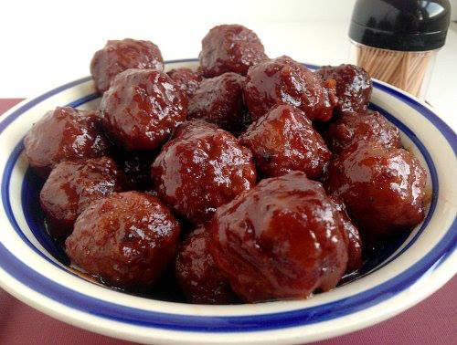
Crockpot Sweet & Sour Meatballs
Serves 6-8
Prep time 5 minutes
Cook time 4 hours
Total time 4 hours, 5 minutes
Meal type Appetizer, Snack, Starter
Ingredients
•10oz chili sauce (one jar)
•16oz grape jelly (one jar)
•2lb frozen meatballs (we used Rosinas)
Directions
1. In a crockpot, add chili sauce and grape jelly. Whisk to combine ingredients and make sauce smooth.
2. Add in meatballs. Stir to coat all meatballs with the sauce. Cover and cook on low for 4 - 6 hours. Serve with toothpicks.

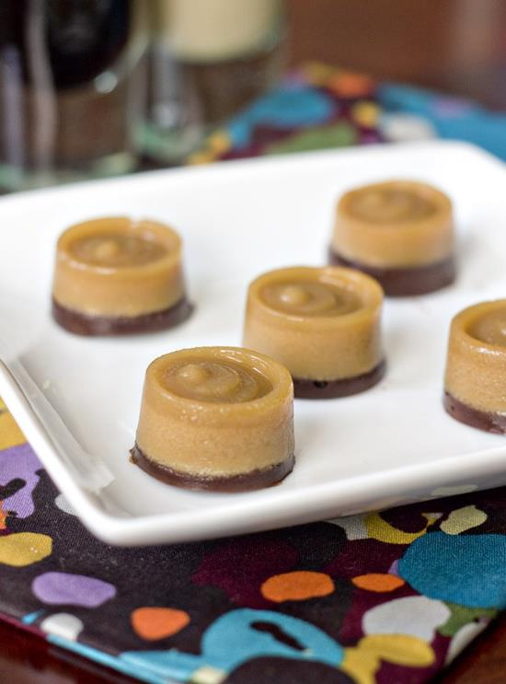
MUDSLIDE JELLO SHOTS
1/3 cup Kahlua liquor
1/3 cup Bailey's liquor
2/3 cup Half and Half
2 envelopes plain gelatin
1/3 cup Vodka
1/2 cup chocolate chips
- Lightly spray mold (I used this one) with non-stick spray and wipe excess off with a paper towel.
- Pour the Kahlua, Bailey's, and half and half in a medium saucepan and sprinkle gelatin on top. Allow the gelatin to soak for 2-3 minutes, then begin to heat on low, stirring constantly until gelatin is fully dissolved (about 5 minutes).
- Remove saucepan from heat and add vodka. Pour into molds, leaving a few millimeters of space in each well for the chocolate. Chill in fridge for one hour.
- Put chocolate chips in a ziploc bag and microwave for 30 seconds. Cut a hole in the corner of the bag and pipe chocolate into each well, until flush with the top of the mold. Return to fridge and chill for another few hours, until completely set.

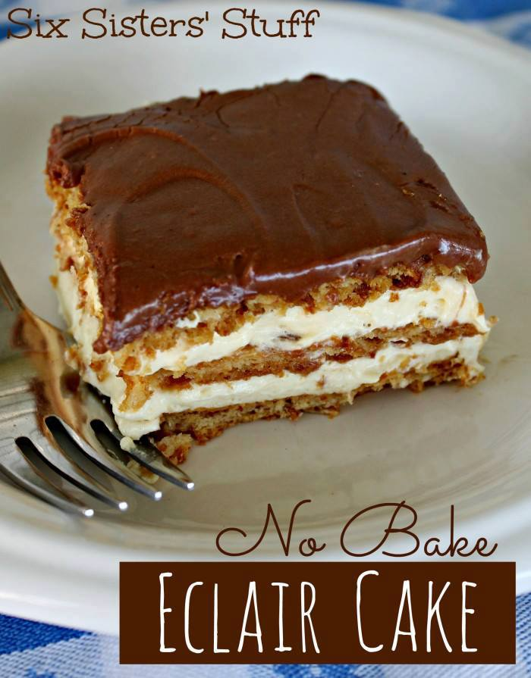
No Bake Eclair Cake
Ingredients:
1 package (1 lb.) graham crackers
2 small french vanilla instant pudding (3.4 ounces each)
3 1/2 cups milk (I used skim)
8 oz. Cool whip
Ingredients for the frosting:
3 tablespoons of Cocoa
1 1/2 cups powdered sugar
3 tablespoons of butter (room temperature)
3 tablespoons of warm milk
Mix above ingredients til smooth. Add more powdered sugar if you like the frosting a little thicker. If it’s too thick, just add a little more milk.
Directions:
Mix pudding and milk in a bowl. Blend together for about 2 minutes then fold in the cool whip.
Spray a 9 x 13 pan with non-stick spray. Place a layer of whole graham crackers on the bottom, then top with 1/2 the pudding.
Cover pudding with another layer of graham crackers, top with remaining pudding and another layer of whole graham crackers, then carefully spread the frosting on the graham crackers.
Chill over night or for at least 8 hours.

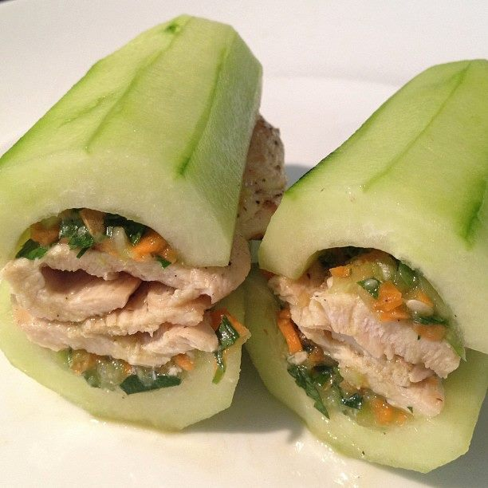
Real cucumber sandwiches
Peel the cucumber and scoop out the seeds with a tea spoon. Relish: one carrot, one stalk of celery, one green onion, a handful of flat leaf parsley, juice of one lime, the scooped out seeds of the cucumber (one), one tbs olive oil, dash of salt, pepper, and Aleppo chili (or cayenne). Blend 5 second in the mixer to keep it chunky.
Taste it and add more lime juice or a splash of vinegar if it is not tangy enough. Slice a chicken breast in thin strips and grill/saute/pan fry them with just a bit of salt and pepper.
Place the cucumber on a plate and scoop some of the relish in it to level it, add the grilled chicken strip, scoop some more relish in the middle on top of the chicken and cover it all with the other part of the cucumber. The whole thing can be juicy, so eat it over a plate. When taken for a lunch, just keep it all separate until it's time to eat and build them on the spot.

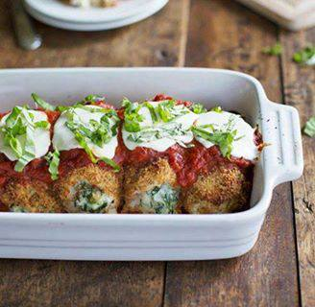
BAKED MOZZARELLA CHICKEN ROLLS
INGREDIENTS
2 lbs. boneless skinless chicken breasts (8 4-ounce pieces)
1 cup whole wheat Italian style bread crumbs
6 tablespoons grated Parmesan cheese, divided
5 ounces fresh baby spinach
1 clove minced garlic and olive oil for sautéing
½ cup part-skim ricotta cheese
⅓ cup beaten egg whites (I used something similar to Egg Beaters)
3 ounces fresh mozzarella cheese, thinly slice
1 cup marinara sauce
fresh basil for topping
INSTRUCTIONS
Prep the chicken: Cut the chicken into 8 pieces and pound the pieces until they are thin (for quick cooking) and have expanded in surface area (for more filling). Place the breadcrumbs in a shallow bowl with 2 tablespoons of Parmesan cheese and set aside.
Prep the filling: Chop the spinach and sauté it with the garlic and just a drizzle of olive oil for 2-3 minutes or until just barely wilted. Combine the sautéed spinach with the ricotta, Parmesan cheese, and 2-3 tablespoons of the egg whites. Place the remaining egg whites in a separate shallow bowl and set aside.
Assemble the chicken: Oil the bottom of a large baking dish and preheat the oven to 450 degrees. Place one piece of chicken on a flat working surface. Put a spoonful of ricotta-spinach filling right in the middle and roll the chicken up so that the edges meet to form a “seam”. Dip the entire chicken roll in egg whites, and then roll it in the breadcrumbs. Place in a baking dish, seam side down. Repeat for the remaining 7 pieces of chicken. Bake for 25 minutes.
Finishing touches: After 25 minutes, the chicken should be cooked through (white on the inside) and browned on the top. Cover the chicken with the marinara sauce and slices of fresh Mozzarella. Bake for another 3-5 minutes or until cheese is melting. Sprinkle with fresh basil.
NOTES
Don’t try to cram all the pieces too close together because if the sides are touching each other, they won’t get crispy. Leaving a little space between each piece allows the breadcrumbs to bake, brown, and crispify perfectly.

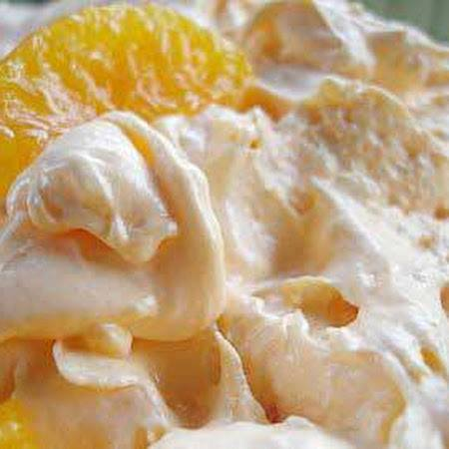
DREAMSICLE SALAD (SUGAR FREE)
A everyday go to dessert with NO guilt!
Try strawberry jello with strawberries and other favors with seasonal fruit.
Ingredients
1 - .3 ozs pkg. sugar free orange jello
1 - 3 ozs. pkg. sugar free instant vanilla pudding
1 - 10 ozs. can mandarin oranges, drained
1 - 8 ozs. tub fat free frozen whipped topping, thawed
Directions
Dissolve jello in 1 c. boiling water. Add 1/2 c. cold water; let /set in fridge for 20 minutes. With mixer or whisk, add dry vanilla pudding mix and beat until smooth. Fold in oranges and whipped topping (by hand). Refrigerate.

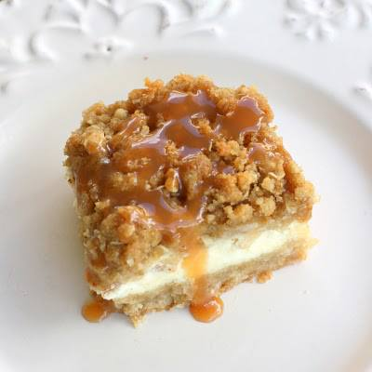
Caramel Apple Cheesecake Bars
Ingredients
Crust:
2 cups all-purpose flour
1/2 cup firmly packed brown sugar
1 cup (2 sticks) butter, softened
Cheesecake Filling:
3 (8-ounce) packages cream cheese, softened
3/4 cup sugar, plus 2 tablespoons, divided
3 large eggs
1 1/2 teaspoons vanilla extract
Apples:
3 Granny Smith apples, peeled, cored and finely chopped
1/2 teaspoon ground cinnamon
1/4 teaspoon ground nutmeg
Streusel Topping:
1 cup firmly packed brown sugar
1 cup all-purpose flour
1/2 cup quick cooking oats
1/2 cup (1 stick) butter, softened
Drizzle:
1/2 cup caramel topping for drizzling after baked
Instructions
Preheat oven to 350 degrees F.
In a medium bowl, combine flour and brown sugar. Cut in butter with a pastry blender (or 2 forks) until mixture is crumbly. Press evenly into a 9x13 baking pan lined with heavy-duty aluminum foil. Bake 15 minutes or until lightly browned.
In a large bowl, beat cream cheese with 3/4 cup sugar in an electric mixer at medium speed until smooth. Then add eggs, 1 at a time, and vanilla. Stir to combine. Pour over warm crust.
In a small bowl, stir together chopped apples, remaining 2 tablespoons sugar, cinnamon, and nutmeg. Spoon evenly over cream cheese mixture.
For the streusel topping: In a small bowl, combine all ingredients. I like to really combine it by using my clean hands to thoroughly combine the butter into the mixture.
Sprinkle Streusel topping over apples. Bake 40-45 minutes, or until filling is set. Drizzle with caramel topping and let cool. Serve cold and enjoy!
Make 16 servings.
Slow Cooker Chicken and Dumplings
Ingredients
2 Tablespoons Butter
4 boneless, skinless chicken breast (or 6 skinless chicken thighs)
1 Onion, finely diced
2 cans of Cream of Chicken Soup
2 small packages Grands Jr biscuits (10 biscuits)
flour
Directions
1. Place the chicken, butter, soup, and onion in a greased slow cooker, and fill with enough water to cover.
2. Secure lid and cook for 5 to 6 hours on High. About 30 minutes before serving, roll each torn biscuit piece in flour (to prevent them from sticking together), then drop into the slow cooker. Replace lid and cook remaining 30 minutes.

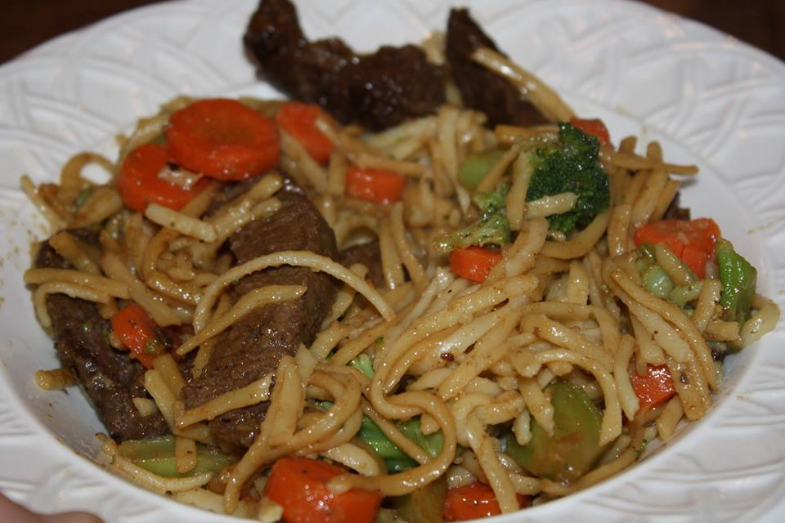
BEEF NOODLE BOWL
8 oz. linguine
3 c. broccoli florets
3 carrots, peeled, sliced
1/4 c. Kraft Asian Toasted Sesame Dressing
2 tsp. oil
1 lb. beef steak, cut into strips
1 Tbsp. teriyaki sauce
1. Cook pasta as directed on package.
Add vegetables for the last 2 minutes. Drain and place in a large serving bowl.
2. Heat oil in skillet. Add meat; cook 4 minutes or until brown on all sides, stirring occasionally.
3. Stir in dressing and teriyaki sauce; cook 2 minutes or until sauce is thickened, stirring occasionally.
4. Add the meat mixture to the pasta mix.
**Enjoy with a little soy sauce and maybe even some fried rice!

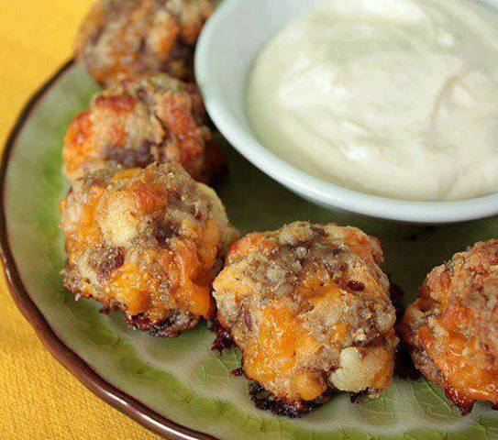
Cream Cheese Sausage Balls with Creamy Mustard Dipping Sauce
"Ingredients:
1 lb. SAUSAGE, uncooked (you can use regular or hot)
8 oz. CREAM CHEESE, softened
1 1/4 cups BISQUICK BAKING MIX( or low carb bake mix)
4 oz. CHEDDAR CHEESE, SHREDDED
Directions:
Preheat oven to 400°.
Mix all ingredients until well combined. Roll into 1 inch balls.
Bake for 20-25 minutes or until golden.
You can make these ahead and refrigerate until needed. Or also freeze until ready to use, you will need to add a few minutes to the baking time.
Dipping Sauce:
1/2 cup MAYO
1/2 cup SOUR CREAM
2 Tablespoons DIJON MUSTARD
1 Tablespoon WHITE WINE VINEGAR
2-6 drops HOT SAUCE
1 medium GARLIC CLOVE, crushed
Combine all ingredients. Chill until serving."

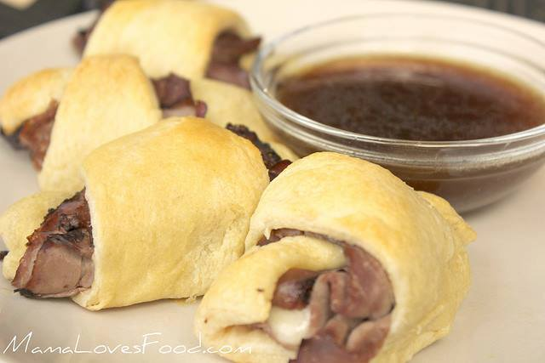
French Dip Crescents
2 packages crescent rolls, 8 count
1 pound deli roast beef, thinly sliced
4 ounces Swiss or provolone cheese, cut in 16 equal sized pieces
optional: Horseradish Sauce
optional: Au Jus for dipping
French Dip Crescent Directions:
Unroll crescents onto a large cookie sheet.
Spread a small dab of horseradish on each crescent, then place a slice of roast beef and a piece of cheese on each crescent.
Roll crescents starting from the wide end and ending at the narrow end.
Bake at 375 degrees for 11 to 13 minutes, until crescents are a golden color.
Serve with Au Jus and enjoy!
Easy Au Jus Ingredients:
olive oil, just enough to saute
1/4 cup red onion, chopped
1 teaspoon garlic, minced (I use jarred)
1/8 cup white wine
1 tablespoon Worcestershire sauce
2 1/2 cups beef broth
1 teaspoon flour
Easy Au Jus Directions:
Caramelize the onions in a small amount of olive oil. Add garlic and cook for a minute or two more.
Deglaze the pot with white wine, then add Worcestershire sauce and cook for another minute, stirring constantly.
Add beef broth and bring to a light boil. Reduce heat and simmer for about 30 minutes.
Strain broth and then return it to pot. Add flour and simmer an additional 5 minutes.
Enjoy!

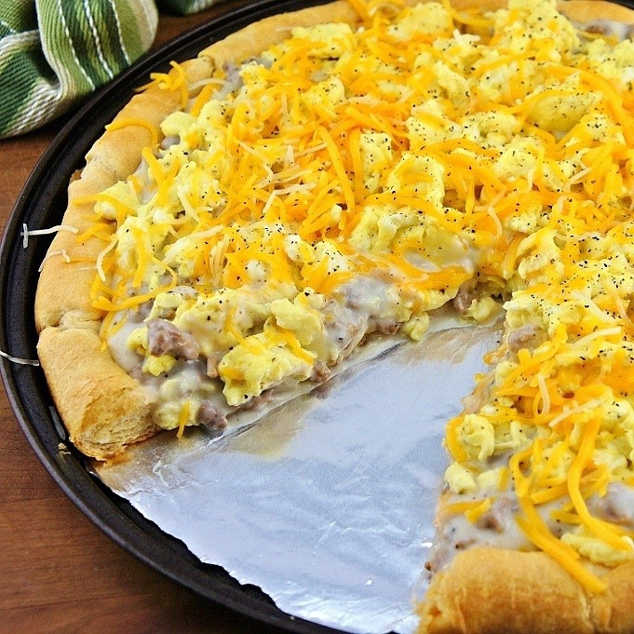
Breakfast Pizza
Ingredients
2 packages crescent rolls
1 package Jimmy Dean cooked sausage crumbles
1 envelope country gravy mix
6 eggs
2 tablespoons milk
1/2 teaspoon salt
1/4 teaspoon pepper
1 tablespoon butter
8 oz shredded cheddar cheese
4 oz shredded pepper Jack cheese
Directions
1. Heat oven to 375. Separate crescent dough into 16 triangles and place on a greased, round pizza pan with points toward the center. Press onto the bottom and up the sides of pan to form a crust; seal seams. Bake for 11-13 minutes or until golden brown.
2. Meanwhile, prepare gravy according to package directions in a medium saucepan. Stir sausage crumbles into thickened gravy; set aside.
3. In a small bowl, whisk together the eggs, milk, salt and pepper. In a large skillet, heat butter over medium heat. Add egg mixture; cook and stir until almost set.
4. Spread sausage gravy mixture over the crust. Top with eggs and cheeses. Bake 5-10 minutes longer or until eggs are set and cheese is melted. Cut into wedges.

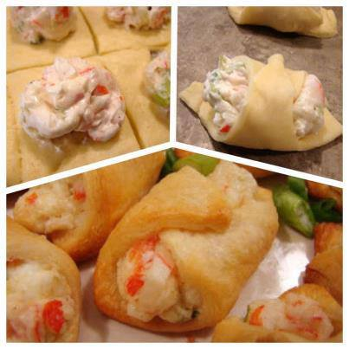
Crab & cream cheese snacks
Tasty appetizer to treat your friends! Be sure to share to keep it i...n your virtual recipe file!
1-8 oz. tube crescent roll dough
3 oz. cream cheese, softened
1/4 cup mayonnaise
3/4 cup cooked crabmeat, chopped
2 green onions, chopped
1/8- 1/4 teaspoon cayenne pepper
salt and pepper, to taste
Heat oven to 375°F. Spray cookie sheet with cooking spray. Unroll dough on work surface. Pinch seams to seal and roll with a rolling pin to create an even rectangle. Cut into 6 rows by 4 rows to make 24 squares.
In small bowl, mix cream cheese, mayo, crabmeat, onion, and red pepper. Salt and pepper to taste. Divide crab mixture evenly among the squares, dropping it by spoonfulls that are 1/2 inch from 1 corner of each square. Starting with same corner, fold dough over filling, and tuck end tightly underneath filling; continue rolling to within 1/2 inch of opposite corner. Roll opposite corner of dough over roll; press to seal. Place on cookie sheet. Brush with egg white, if desired.
Bake 10 to 15 minutes or until golden brown. Remove from cookie sheet. Serve warm.

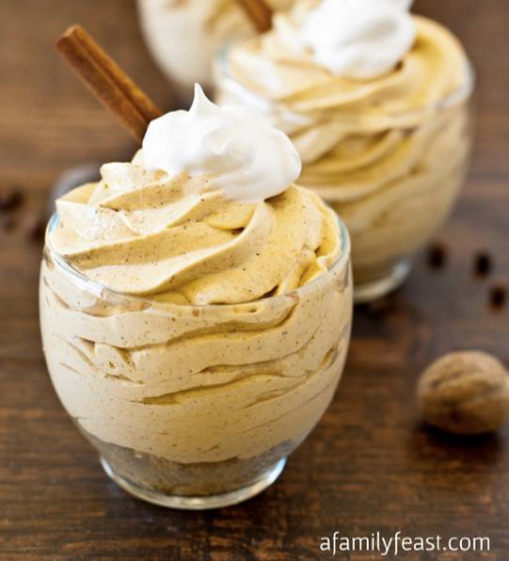
NO BAKE PUMPKIN CHEESECAKE

For the crust
1 sleeve graham crackers (about 9 crackers)
½ stick (4 tablespoons) butter, melted
2 tablespoons sugar
2 tablespoons brown sugar
For the Cheesecake filling
1 8-ounce package cream cheese,
1 15-ounce can pumpkin puree
3 teaspoons pumpkin pie spice
1 1-ounce package cheesecake-flavored instant pudding mix
1 14-ounce can sweetened condensed milk
1 12-ounce container frozen whipped topping, plus extra for garnish if desired

Instructions
Place the graham crackers in the bowl of a food processor and pulse the crackers into fine crumbs.
Add the melted butter, sugar and brown sugar and pulse until combined.
Spoon the crumbs into individual 9-ounce plastic cups (or other individual sized cups for serving). Place in the refrigerator to set while you are preparing the filling.
In the bowl of a stand mixer with the paddle attachment, beat the cream cheese until light and creamy.
Add the pumpkin, pumpkin pie spice, and pudding mix and beat until completely mixed, scraping down the sides and bottom of the bowl to ensure that all ingredients are well combined.
Add the sweetened condensed milk and mix again until well combined.
Change your stand mixture attachment to the wire whisk. On slow speed, fold in the tub of Cool Whip until well combined.
Allow the mixture to sit in the refrigerator for about an hour to firm up.
Using a large pastry bag with a large tip, or a spoon, top the graham cracker crust in each cup with the pumpkin mixture and refrigerate until ready to serve.
Garnish with additional whipped topping if desired.

